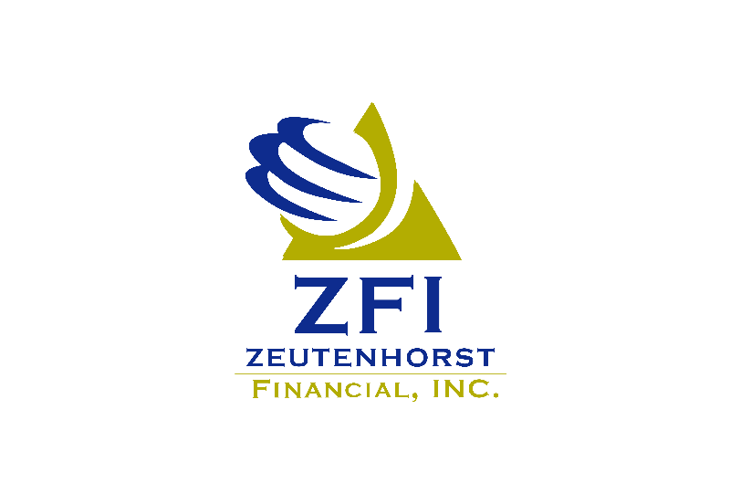
Investment Operations

At Zeutenhorst Financial, we believe a vital part of building a fulfilling future for our clients is through securing their financial well-being. With over forty years of experience in the financial industry, we at ZFI understand how to ask the right questions to keep you safe and prepare for the unexpected. We have a long-standing commitment of building a culture of professional excellence and continuous learning through the way we treat our employees and our clients.

Supported by Equitable Advisors, we offer a variety of financial products and services that are designed to help our clients plan, build, and achieve a more stable financial future for them and their loved ones. Located in Sioux Center, Iowa, our experienced professionals are ready to walk alongside you to provide clear recommendations and options to help meet your financial goals and make the most of what you have earned and saved.

We are a small but passionate group of individuals, dedicated to providing the highest quality of customer service to our customers and ensuring all their needs are met.

Position highlights:
The Investment Operations position is responsible for the day-to-day operations of the investment department. This position supervises and monitors investment account administration; provides excellent customer service; manages and maintains online systems that are both client facing and used internally; and facilitates departmental processes. The Investment Operations position performs tasks and services to support effective and efficient operations of the investment department.

Essential Duties and Responsibilities
The Operations position must be proficient in a variety of tasks to support Financial Advisors. This involves, but is not limited to, the following:
- Manage and maintain schedules, priorities, deadlines, and workflows.
- Prepare for appointments; process and follow through on client paperwork.
- Interact with clients in person and over the phone.
- Daily service, support, research, and problem solving. Maintain client databases.
- Plan, progress, and monitor projects.

Key Qualities
- Commitment and drive for professional growth and continuing education – willing to earn a financial planning educational program leading to certification within the first year
- Precise attention to detail and strong organizational skills
- Motivation to continuously improve processes and tools
- Demonstrated ability to work independently and anticipate and solve problems in fast-paced environment
- Clear and effective communication skills amongst a diverse team
- A quick learner of financial planning software and other technologies

Education & Experience
- Maintain or acquire a series 7 license in the first 12 months after date of hire
- 3+ years of relevant professional experience preferred
- A bachelor’s degree, preferred in finance, accounting, economics, or equivalent combination of education and experience

Physical Requirements
- Must be able to learn technical material and communicate in a clear and effective manner in person, by phone, and via email and exchange accurate information in these situations
- Must be able to constantly operate a computer and other office productivity machinery, such as copy machine
- Must be able to lift up to 15 pounds at a time.

Zeutenhorst Financial is an equal opportunity employer. All qualified applicants will receive consideration for employment without regard to race, color, religion, gender, national origin, disability, protected veteran status, sexual orientation, age, or any other characteristic protected by law.

This job description is subject to change at any time.

PPG-8392648.1(9/25)(Exp.9/29)

