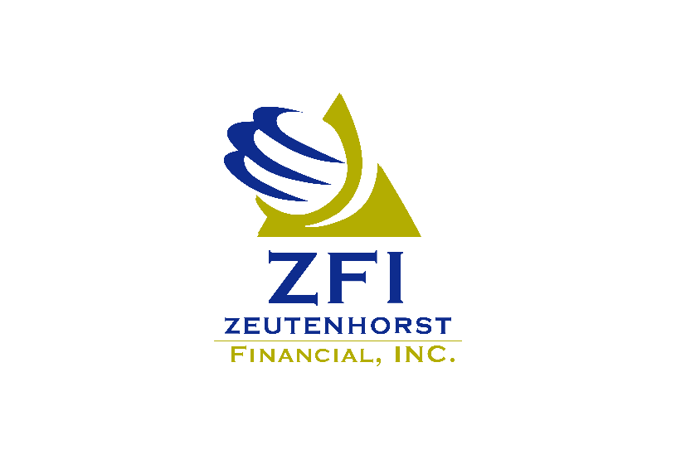

Benefits: Director and HR Specialist

At Zeutenhorst Financial, we believe in empowering others through life with purpose. We strive to simplify the complex, whether it be insurance, investments, or business management services. Established in 1981, our financial advisors and staff work with individuals and families to help lay out a plan that outlines their goals and set a course for achievement.

Job Summary
The Director of Benefits and HR Services is responsible for overseeing the day-to-day operations of group benefits programs and administering fractional HR services. This role involves supervising and monitoring benefits administration, providing excellent customer service, and managing and maintaining online systems that are both client-facing and used internally. Key responsibilities include:
- Facilitating employee and open enrollment meetings as needed.
- Ensuring timely responses to regular service requests from clients.
- Supporting effective and efficient operations of the Benefits Department.
- Administering all insurance benefits for group clients.
The Director may also perform tasks and services to support the overall objectives of the department, ensuring seamless integration between benefits administration and HR services.

Primary Responsibilities
These are the core duties essential to the position:
- Team Leadership and Oversight
- Oversee the Benefits Team and provide clear direction to ensure seamless operations.
- Participate in strategic planning for the company, ensuring alignment with organizational goals.
- Deliver outstanding customer service to both internal and external customers.
- Respond promptly to benefit inquiries regarding plan provisions, enrollments, claims, and other general matters.
- Ensure timely, consistent, and accurate resolution of service requests, with thorough follow-up and follow-through until completion.
- Benefits Administration and Open Enrollment
- Oversee, design, and implement the open enrollment process, including bidding, benchmarking, and renewal of benefit plans.
- Manage enrollment processes, distribute materials for orientations, onboard new employees, and process terminations.
- Facilitate scheduling, preparation, and follow-up for renewal meetings, educational seminars, and other formal events.
- Compliance Management
- Ensure compliance with government regulations and oversee timely accuracy of reporting and fees.
- Research, generate, and distribute compliance documents and communications to enhance understanding of benefits and related laws.
- Generate and manage ERISA Wrap compliance documents, distributing them regularly to clients.
- Systems Administration
- Administer benefits and human resources information systems (HRIS) with attention to detail and accuracy.
- Ensure vendors receive accurate eligibility information and maintain group benefits databases.
- Daily Benefits Processing
- Coordinate enrollments, COBRA, terminations, changes, beneficiaries, and claims.
- Maintain filing systems and ensure proper documentation in supporting systems.
- Perform quality checks on benefits-related data and revise internal processes for efficiency.

Secondary Responsibilities
These are additional duties that support the overall objectives of the department:
- HR Services Administration
- Provide HR services for group clients and employees, including onboarding, life status changes, and benefits enrollment.
- Manage HR projects for clients and ensure accurate tracking and invoicing of HR services.
- Marketing and Communication
- Implement email marketing campaigns for group benefit clients and retirement savings education.
- Distribute compliance news and educational content to employers periodically throughout the year.
- Cross-Departmental Support
- Support the accounting department with bill pay and payroll tasks as needed.
- Collaboration with Specialists
- Partner with the customer service team to ensure consistent and timely responses to service requests.

Required Skills/Abilities
- Extensive knowledge of employee benefits and applicable laws.
- Excellent written and verbal communication skills.
- Excellent organizational and time management skills.
- Proficient with Microsoft Office Suite or similar software.
- Ability to work independently and to anticipate and solve problems in a fast-paced environment.
- Aptitude to learn technical material and communicate in a clear and effective manner in person, by phone, and via email and exchange accurate information in these situations.

Education and Experience
- SHRM certification is preferred.
- 3+ years of relevant professional experience in the HR, benefits, financial, accounting, banking, or related industry
- Associates degree in HR or related field, but experience and/or other training/certification may be substituted for the education.
- Iowa Life and Health insurance license (can be earned after date of hire, in the first 6 months)

Physical Requirements
- Prolonged periods sitting at a desk and working on a computer.
- Must be able to lift up to 15 pounds at a time.

Zeutenhorst Financial is an equal opportunity employer. All qualified applicants will receive consideration for employment without regard to race, color, religion, gender, national origin, disability, protected veteran status, sexual orientation, age, or any other characteristic protected by law.

This job description is subject to change at any time.

PPG-8392674.1(9/25)(Exp.9/29)

