Personal Financial Survey

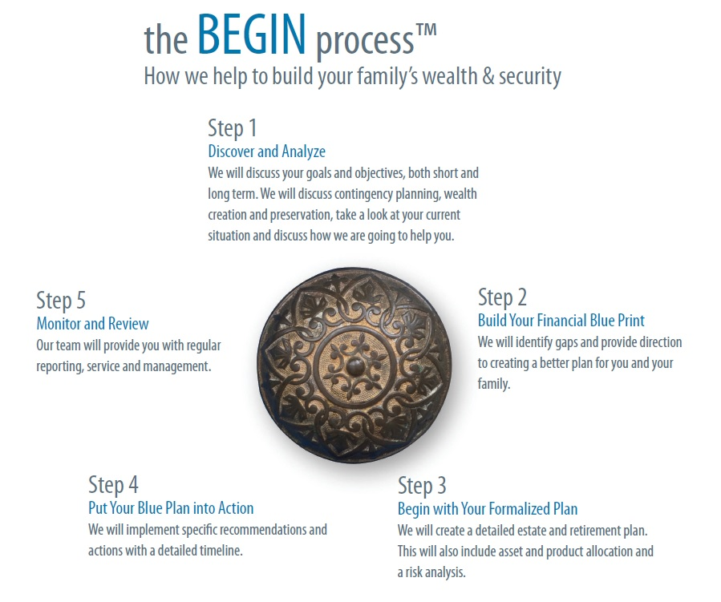
Simplify your financial life so you can spend more time with the people you care about.
Enter and Begin with our simple 5-step financial planning process. Financial planning takes the guesswork out of managing your finances and helps you understand the implications of each financial decision you make. Everyone has different goals and dreams for their families and because of this, we are focused on providing customized advice for our clients, tailored to their own situations.
1. Personal Background Information

Let’s begin with you.
To get us started, we need to gather some of your personal information. This ensures our files are current for client contact and help to fulfill any regulatory requirements we have.

Your Information:
First and Last Name:
Address:
Social Insurance # and date of birth
Home and Business Phone #
Email address
Occupation, Place of Employment, Income
Accountant and Phone #
Lawyer and Phone #
Smoker Y/N, Health Problems
Hobbies or Special Interests

Spouse Information:
First and Last Name:
Address:
Social Insurance # and date of birth
Home and Business Phone #
Email address
Occupation, Place of Employment, Income

Additional Information:
Driver’s License Number for Each
Name of Bank
Address of Bank
Children’s names, Date of Birth, SIN #

2. SMART Goals, Assumptions & Your Knowledge

How SMART are your goals?
In order to identify your financial objectives, we will work together to create goals that are:

- Specific – clearly defined and described in detail
- Measurable – show and track your progress
- Attainable – realistic and reachable
- Relevant – specific to your needs and values
- Timely – subject to a clear deadline

To better understand your goals, we ask that you prioritize what’s important to you.
With the list of items below, please identify each item’s importance to you and your family. Do this by placing as many check marks beside the appropriate response as necessary. If there is something else that you would like to enter, please feel free to do so.
ITEM | IMPORTANCE
 | Very Unimportant | Unimportant | Important | Very Important | Extremely Important
Managing Retirement Income
Save for Retirement
Maximize RRSPs
Reduce Income Tax
Planning my Estate
Post-Secondary Education
Reduce/eliminate consumer debt
Pay down mortgage
Travel/Vacations
Care for elder relatives
Maximizing my Estate
Others:

Our Assumptions.
Please review the common planning assumptions we make about economic indices. If you would like us to use a different value for any of the following, please list your change in the space provided.

 | Our Assumption | Your Change
RETIREMENT AGE – at what age to you wish to Retire? | 65
Do you wish to include CPP and OAS? | YES
Inflation – the historical inflation rate is used to index personal items such as lifestyle expenditures and earnings. | 3.0
Post-Secondary Tuition Cost Index – The tuition rate is used to index the cost of post-secondary education. | 8.0
Real Estate Index – the real estate index is used to simulate the equity growth on properties such as your house. | 2.0
Before Tax Equity Investment Return – We will use either this general equity investment return or the historical data for asset growth. | 6.0
Before Tax Interest Investment Return – For interest bearing investments, We will use either this general interest investment return or the historical data. | 3.5

Investment Knowledge/Level of Service Required (Please select one)

☐ I don’t have any (or have very few) investments right now.

☐ I don’t have the time or knowledge to manage my investments.

☐ I am interested in learning more. I would like you to explain financial planning concepts in detail.

☐ I am comfortable discussing relatively complex financial planning concepts.

☐ I need help with only with implementation of my investment portfolio.

How Often Would You Like To Meet For A Review?

☐ Annual

☐ Semi-Annual

☐ Quarterly

☐ Monthly

3. Your Net Worth

Tell us about what you own.
Please list the current values of your assets or provide us with your most recent statements where applicable. This section allows us to calculate a more accurate Net Worth Statement.

Personal Assets | Self | Spouse | Joint | Other
Residence
Cottage
Vehicles
Other
Other
Other

Please note: Do NOT fill out the three charts below if you provide us with your most recent statements for the following.

Liquid Assets | Self | Spouse | Joint | Other
Cash & Chequing
Savings Account
Short Term Deposits
Canada Savings Bonds
T-Bills
Cash Value of Life Insurance

Non-Registered Assets | Self | Spouse | Joint | Other
Money Market Funds
Term Deposits & GIC’s
Mutual Funds
Canadian Stocks
US Stocks
Limited Partnerships
Other Investments

Other Investments

Registered Retirement Assets (RRSP/RRIF) | Self | Spouse | Joint | Other
Money Market Funds
Term Deposits & GIC’s
Mutual Funds
Canadian Stocks
US Stocks
Limited Partnerships
Other Investments

Other Investments

Regular Investment Contributions | Self | Spouse | Joint | Frequency
Pension Plan |  |  | n/a
RRSP |  |  | n/a
RESP |  |  | n/a
Non-Registered
Short-term Savings
Other Investments

Other Investments

Other Assets – Important for Business Owners

Do you own an interest in a private business corporation, partnership, professional practice or rental properties? If yes, please describe and provide latest financial statements and tax returns, if applicable. These statements will help us to understand where your income is coming and may provide information for tax savings ideas and strategies. Please inform us as well if you have a partnership agreement or contingency plan for your business. If so, please tell us what your contingency plan is in the space provided below. We can then review your partnership agreement and contingency implementation to ensure that what you want to have happen will actually happen.

4. Liabilities

What are you liable for?
Please list any short and long-term obligations for you and your spouse, and place a star beside those loans which interest is tax deductible. Do NOT complete this section if you provide us with your most recent mortgage statement, loan statement, etc.

 | Current Balance | Interest Rate | Monthly Payment | Final Payment
Short Term Obligations
Credit Cards
Department Store Credit
Car Loan
Bank Loan
Other

Other

Long Term Obligations
Investment Loans
Business Loans
Mortgage on Residence
Vehicle Loans
Loans on Personal Assets
Other

Other

5. Your Retirement

Retirement expenditures that fit your lifestyle.
What does your retirement look like? This section is NOT meant to be a budget; it is used to help you find out where your money is going now, and where it will go during your retirement. Please be as thorough as possible – this is the most important aspect of the Retirement Planning Process. If you think your expense in any one category will be significantly different in retirement than it is now (i.e. vacations), please enter the number in the Retirement Column. Use current dollars only. Note that we will adjust for inflation.

Type | Current Expenses  ☐ $ per month  ☐ $ per year  ☐ use details below | Retirement  ☐ $ per month  ☐ $ per year  ☐ use details below  ☐ please estimate for me
Housing Costs
Mortgage PMT | (attach statement) | WE WILL CALCULATE, IF ANY.
Rent
Property Taxes
Insurance
Utilities
Maintenance
Living Expenses
Food
Telephone
Cable / TV
Personal Care
Clothing
Medical/Dental
Child care
Education
Transportation
Lease Payment
Car Insurance
Gas/Oil
Maintenance
Bus/Taxi

Insurance Expenses (ignore if policies provided)
Disability Ins.
Health Care
Life Insurance

Investment Expenses
Business Loans
RRSP Loan
Investment Loan
Other
Recreation Expenses
Videos
Sports
Trips/Vacations
Other
Other
Discretionary
Charitable
Dining Out
Alcohol
Tobacco
Entertainment
Miscellaneous
Personal Loans
Other
Other
Other
Other
Other

6. Your Estate Plan

What is Estate Planning?
Estate Planning is about LIFE – in the present and in the future. Most importantly, estate planning is about the life of your family and loved ones – and the peace of mind you get from helping to preserve their financial security.

By its very nature, estate planning is a difficult subject to discuss; it forces us to come to terms with our own mortality. Yet it is something you need to talk about openly with your loved ones today, as you can’t do so after you are gone – or after they are gone.

Estate Planning should be a reflection of your own personal priorities and choices.

Estate planning is generally guided by three RATIONAL motivations:

- Provide adequately for family members
- Ensure that your estate is distributed in the most timely manner possible after your death
- Minimize taxes – during your lifetime and, equally important, for the beneficiaries of your estate

… and three EMOTIONAL motivations

- Gain comfort from knowing your loved ones are well looked after
- Feel secure knowing that settling your affairs will not add more stress to those grieving for you
- Rest assured that your estate will be distributed the way you wish

What does Estate Planning accomplish?
- Keeps more of your money in the hands of your heirs
- Minimizes taxes and probate fees; designates charitable gifts; declares your personal care preferences, including terminal medical treatment
- Provides for income splitting
- Distributes your assets as YOU intended; provides funds to cover funeral expenses, as well as immediate and/or long-term family living expenses
- Ensures business continuity for business owners
- Identifies the people chosen to carry out your last wishes and care for your minor children

You have already answered many of the questions necessary to create an estate plan.
The following questions still remain.

Your Will and Power of Attorney:

When was your Will last updated?

Who are your executors/executrix?

What is your relationship to your executors/executrix?

Do you have children? If so, have you named a guardian for your child/ren?

Do you have a Power of Attorney for property and personal care?

Do you have a Partnership agreement and/or a contingency plan for your business? What does it say?

Your Estate Distribution:

Who do you want to benefit from your estate planning?

What do you want them to be able to do as a result of your planning?

How do you want to be remembered?

7. Education Funding

It’s time to start saving for your child’s education.
Perhaps your potential graduate is still in diapers. But, given the high cost of post-secondary education, you'd be smart to start a systematic savings plan now. Many assumptions are used when planning for education funding. For example, you have indicated in Section 2 an inflation level for the cost of education over the next many years. The questions below will help answer other questions that will impact on our recommendations.

1. How much of your child’s education would you like to pay for? Many parents tell us that they will not pay for ALL of a child’s education, but will share the expense in some way with the child. Indicate in a percentage (0 – 100%) how much you plan on contributing.

2. What happens if your child does not choose to attend a post-secondary institution? Would the money you have saved still go to the child?

3. How many children do you have?

4. Did you attend a post-secondary institution? College, University, trade school?

5. Do you currently have any savings?

6. Do the child’s grandparents have an education fund already set up? If so, this may have an impact on the Education grants the Federal Government hands out.
You’re done!
Thank you for completing this Personal Financial Survey and I look forward to discussing your personal financial plan at our next meeting.

