Weekly Market Commentary
February 14th, 2022

Hi,
A hot inflation print and the growing concern of a Russian invasion of Ukraine sent stocks tumbling late in the week, leaving major indices lower for the five-trading days.
The Dow Jones Industrial Average skidded 1.00%, while the Standard & Poor’s 500 retreated 1.82%. The Nasdaq Composite index slumped 2.18%. The MSCI EAFE index, which tracks developed overseas stock markets, advanced 2.26%.^{1,2,3}

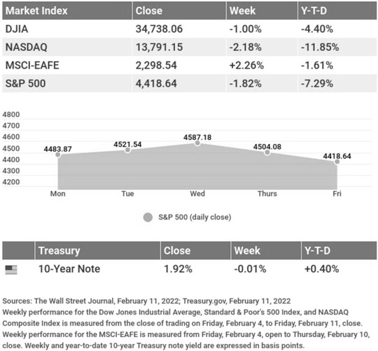

A Double Whammy
Mid-week, a fresh batch of positive corporate earnings surprises lifted investor sentiment, helping stocks claw back losses with technology stocks posting some of the sharpest gains. But January’s inflation report, set for release on Thursday morning, remained investors’ biggest concern.
When the report hit, it showed accelerating inflation, and stocks dropped and bond yields bounded higher. Stocks managed to recover from the initial reaction to the unexpectedly high inflation number. But when the President of the Federal Reserve Bank of St. Louis commented that the Fed may consider a more aggressive move against inflation, stocks resumed their slide lower. The stock skid accelerated into Friday on White House reports that an invasion of Ukraine by Russian forces may be imminent.⁴

Inflation Sizzles
Prices of consumer goods accelerated in January, rising 0.6% from the previous month and 7.5% year-over-year. This annual inflation rate was the highest since 1982. Core inflation, which excludes the more volatile food and energy prices, was 6.0% higher from last January.⁵
Many economists and market analysts had expected inflation to moderate, but driven by a surge in prices of used cars, gasoline, and energy, inflation remained at elevated levels. The persistence of inflation at these heights has fueled investor concerns that the Fed might consider a more aggressive 50-basis points increase in short term interest rate.

This Week: Key Economic Data
Tuesday: Producer Price Index (PPI).
Wednesday: Retail Sales. Industrial Production. FOMC Minutes.
Thursday: Housing Starts. Jobless Claims.
Friday: Existing Home Sales. Index of Leading Economic Indicators.
Source: Econoday, February 11, 2022
The Econoday economic calendar lists upcoming U.S. economic data releases (including key economic indicators), Federal Reserve policy meetings, and speaking engagements of Federal Reserve officials. The content is developed from sources believed to be providing accurate information. The forecasts or forward-looking statements are based on assumptions and may not materialize. The forecasts also are subject to revision.
This Week: Companies Reporting Earnings
Tuesday: Zoetis, Inc.(ZTS), Devon Energy Corporation (DVN), Marriott International, Inc. (MAR), ViacomCBS, Inc. (VIAC).
Wednesday: Nvidia Corporation (NVDA), Cisco Systems, Inc. (CSCO), Applied Materials, Inc. (AMAT), Shopify, Inc. (SHOP), DoorDash (DASH).
Thursday: Roku, Inc. (ROKU), Walmart, Inc. (WMT), The Southern Company (SO).
Friday: Deere & Company (DE).
Source: Zacks, February 11, 2022
Companies mentioned are for informational purposes only. It should not be considered a solicitation for the purchase or sale of the securities. Investing involves risks, and investment decisions should be based on your own goals, time horizon, and tolerance for risk. The return and principal value of investments will fluctuate as market conditions change. When sold, investments may be worth more or less than their original cost. Companies may reschedule when they report earnings without notice.

“I imagine one of the reasons people cling to their hates so stubbornly is because they sense, once hate is gone, they will be forced to deal with pain.“

– James Baldwin

How to Verify Your Identity When Calling the IRS
When calling the IRS, you can expect them to verify your identity before delving into personal information. Here’s what you’ll need to verify your identity:
- Social Security number.
- Birthdate.
- An Individual Taxpayer Identification Number if you have one instead of your SSN.
- Your filing status.
- Your prior tax return. You may need information from your prior year’s return to answer certain questions.
- A copy of the tax return you’re calling about.
- Any letters or notices you’ve received from the IRS.

Having all this information handy before you call the IRS will make the process faster because IRS phone operators will only speak with the taxpayer or a legally designated representative.
* This information is not intended to be a substitute for specific, individualized tax advice. We suggest that you discuss your specific tax issues with a qualified tax professional.
Tip adapted from IRS.gov⁶

How to Get the Recommended 10,000 Steps a Day
Getting 10,000 steps in throughout the day (or moving at all!) might sound like an impossible goal, but there are a few small tweaks you can make throughout your day to get those feet moving. Here are a few ideas:
- When running errands, park your car further away and walk from there.
- Create a “loop” in your hours that you can walk in between meetings or when you need to get up from your desk. Your loop could even be around the kitchen island!
- Walk in place while watching TV.
- Listen to a great podcast or audiobook while you walk. It will make the time go by faster!
Tip adapted from Organizing Moms⁷

What is the smallest number of cars that can be driven down the road in this formation: two cars ahead of a car, two cars behind a car, and a car between two cars?
Last week’s riddle: They never move, even when we walk on them, but signs and arrows may indicate that they go “up” and “down.” What are they? Answer: Stairs.

The Blue Domed Churches of Agios Spyridonas and Anastaseos, Oia, Santorini, Greece.

Footnotes and Sources
1. The Wall Street Journal, February 11, 2022
2. The Wall Street Journal, February 11, 2022
3. The Wall Street Journal, February 11, 2022
^{4. CNBC, February 10, 2022}
^{5. CNBC, February 10, 2022}
^{6. IRS.gov, September 1, 2021}
7. OrganizingMoms.com, September 30, 2020
Investing involves risks, and investment decisions should be based on your own goals, time horizon, and tolerance for risk. The return and principal value of investments will fluctuate as market conditions change. When sold, investments may be worth more or less than their original cost.

The forecasts or forward-looking statements are based on assumptions, may not materialize, and are subject to revision without notice.

The market indexes discussed are unmanaged, and generally, considered representative of their respective markets. Index performance is not indicative of the past performance of a particular investment. Indexes do not incur management fees, costs, and expenses. Individuals cannot directly invest in unmanaged indexes. Past performance does not guarantee future results.

The Dow Jones Industrial Average is an unmanaged index that is generally considered representative of large-capitalization companies on the U.S. stock market. Nasdaq Composite is an index of the common stocks and similar securities listed on the NASDAQ stock market and is considered a broad indicator of the performance of technology and growth companies. The MSCI EAFE Index was created by Morgan Stanley Capital International (MSCI) and serves as a benchmark of the performance of major international equity markets, as represented by 21 major MSCI indexes from Europe, Australia, and Southeast Asia. The S&P 500 Composite Index is an unmanaged group of securities that are considered to be representative of the stock market in general.

U.S. Treasury Notes are guaranteed by the federal government as to the timely payment of principal and interest. However, if you sell a Treasury Note prior to maturity, it may be worth more or less than the original price paid. Fixed income investments are subject to various risks including changes in interest rates, credit quality, inflation risk, market valuations, prepayments, corporate events, tax ramifications and other factors.

International investments carry additional risks, which include differences in financial reporting standards, currency exchange rates, political risks unique to a specific country, foreign taxes and regulations, and the potential for illiquid markets. These factors may result in greater share price volatility.

Please consult your financial professional for additional information.

This content is developed from sources believed to be providing accurate information. The information in this material is not intended as tax or legal advice. Please consult legal or tax professionals for specific information regarding your individual situation. This material was developed and produced by FMG Suite to provide information on a topic that may be of interest. FMG is not affiliated with the named representative, financial professional, Registered Investment Advisor, Broker-Dealer, nor state- or SEC-registered investment advisory firm. The opinions expressed and material provided are for general information, and they should not be considered a solicitation for the purchase or sale of any security.

Copyright 2022 FMG Suite.

