Maiorano & Associates, Inc.
8754 Bay 16th St Brooklyn NY 11214
P:718-331-3700 F:718-331-1290
Maioranotaxandfinancial.com
Market Volatility:
A Part of the Investment Experience

June 2021
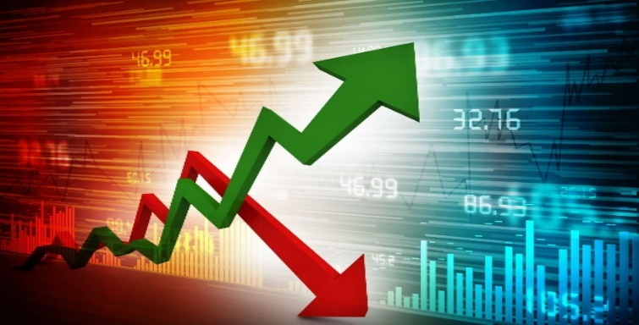

Market volatility is a part of the investment experience and seasoned investors understand that acting emotionally can be more harmful than helpful. It is always appropriate to understand and prepare for market volatility and downturns, even when markets are going up. Investors should not let market movements force them to lose focus. A knowledgable investor understands that markets go up but they also can go down.

Volatility is a statistical measure of the distribution of returns for a given security or market index. For example, when the stock market rises and falls more than one percent over a sustained period of time, it is called a "volatile" market.

The U.S. economy is not supposed to be highly volatile, but equity markets are a different story. Market volatility doesn’t mean that stocks are headed for a down or bear market. Even if there are market corrections along the way an investor can still potentially experience reasonable returns over a long period of time.

What is stock market volatility?

Stock market volatility is a measure of how much the stock market's overall value fluctuates up and down. Just like equity markets, individual stocks can also experience volatility. An investor can calculate volatility by looking at how much an asset's price varies from its average price. Standard deviation is the statistical measure commonly used to represent volatility.

Some stocks are more volatile than others. Shares of an established large blue-chip company may not make very big price swings, while shares of a high flying and newer tech company may do so often. Stock market volatility can occur, especially when external events create uncertainty.

Why is volatility important?

By understanding how volatility works, you can put yourself in a better position to evaluate stock market conditions as a whole. You can then analyze the risk involved with any particular security and construct a stock portfolio that is a great fit for your growth objectives and risk tolerance.

It's important for investors to be aware that volatility and risk are not the same thing. For stock traders who look to buy low and sell high every trading day, volatility and risk are deeply intertwined. Volatility also matters for those who may need to sell their equities in a short time-frame, such as those who are older and closer to retirement.

For long-term investors who tend to hold equities for many years, the day-to-day movements of those equities need to be understood. Volatility is part of the noise that could come while you are allowing your investments to compound long into the future.

Long-term investing still involves risks, but those risks are usually related to being wrong about a company's growth prospects or paying too high a price for that growth -- not volatility.
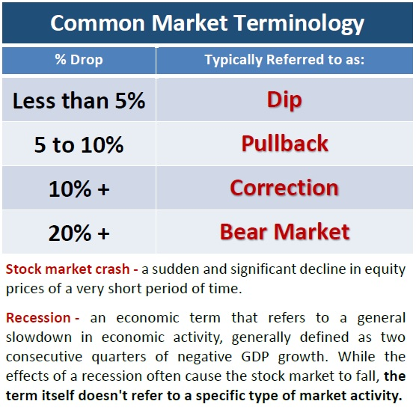
A quick review of some market terms.

Oftentimes, we hear the wrong words used in the wrong context. For educational purposes, we feel it is important to clarify some stock market words and their definitions.
“Dip” - a short-lived downturn from a sustained longer-term uptrend.
Example: Equity markets increased by 5% and maintained that level and then dipped back down to 3% all within a few days or weeks.
“Correction” - a 10% drop in the market from recent highs. Historically corrections occur an average of about every eight to 12 months and last about 54 days. (thebalance.com 3/9/20)
Example: On December 17, 2018, both the DJIA and the S&P 500 dropped over 10% and declines continued into early January.
“Bear Market” - a long, sustained decline in the stock market. If the market declines 20% from its recent high, this is considered the start of a bear market.
Example: On Wednesday, March 11, 2020, The DJIA dropped 5.9%, for a total decline of 20.2% from a record high on February 12, 2020.
“Crash” - a sudden and dramatic drop in stock prices, often on a single day or week. Crashes are rare, but typically happen after a long-term uptrend in the market.
Example: In 1929 the market crashed when it lost 48% in less than two months, ushering in the Great Depression.
Position yourself to best
navigate market volatility.
No matter what equity markets are doing, your plan should align itself with these three items.
- Your investing goals;
- Your financial timeline; and
- Your risk tolerance.
Your Investing Goals
Every investor has unique goals they would like to attain. Knowing what your goals are is the first step to creating a path to achieve them. Your goals will determine your time horizon and risk tolerance.
Your Financial Timeline
Focus on your personal timeline instead of trying to time the market. During downturns, it may be tempting to pull out of the market, but you may miss out on a healthy recovery. Try to plan for your equity investments to maintain a long-term horizon and ignore the short-term fluctuations.
Remember, short-term movements of the market are unpredictable and do not abide by any average. For many long-term investors there is no reason to even subject themselves to daily market headlines. If you have a long-term investment horizon for your equity holdings of at least five years, chances are the current volatility will pass - possibly in a couple of weeks, months or at the most, a few years.
According to a JP Morgan analysis, even missing a few days of a market recovery can be costly. This analysis looked at the S&P 500 over a 20-year period (January 2000 to December 2019). Investors who stayed fully invested would have earned more than 6% annually. However, those investors who missed just 10 of the days with the highest daily returns would have earned only 3% annually. During those 20 years, six out of the 10 best days occurred within two weeks of one of the worst 10 days.

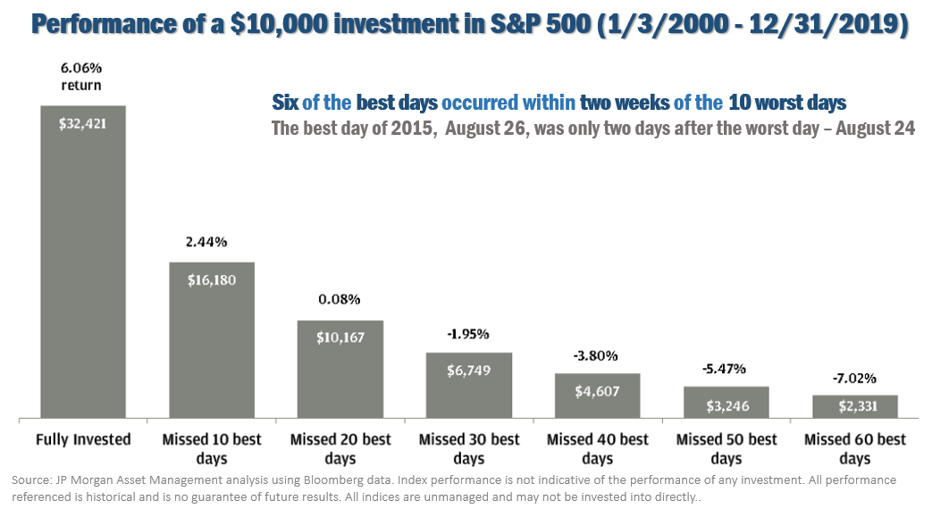
Your Risk Tolerance
Risk tolerance is the level of uncertainty you are willing to accept in order to reap potentially greater rewards. Knowing what your risk tolerance is, or risk awareness, should be part of your financial plan. As your financial professional, one of our primary goals is to help you create a plan that considers your risk tolerance. If you are not quite sure what your risk tolerance is, call us and we can help assess and determine this for you.
What should an investor do
in a volatile market?
First, make sure you know what not to do: and that is panic. In times of market volatility, investors tend to become unnerved and anxious. This is usually not the best mindset to make rational decisions. When equity markets experience unsettling fluctuations, we suggest you ask yourself three questions:
- Have my financial timelines changed?
- Have my financial goals changed?
- Has my risk tolerance changed?

If you can answer “YES” to any of these questions, we highly suggest that you discuss these changes with us. As an investor, you need a plan that includes risk awareness.
One of our primary responsibilities as your financial professional is to help create a plan with risk awareness.
We know that an integral part of this is to consistently keep in touch with you and monitor your situation.
If you have concerns, some questions to ask us include:
- Can we review my financial plan?
- Can we revisit my risk tolerance?
- Are my investments diversified?
- Has the volatility presented any good opportunities?
Volatility vs. Risk:
Volatility and risk are not the same thing. When a stock is volatile, it means that it tends to make big moves (up or down). When a stock is risky, it means that it can lose money (go down). In financial terms, risk is the potential permanent loss of money whereas volatility is how rapidly an investment tends to change in price. Volatility does not just imply risk of loss – it simply refers to the price action. Some investments may be more volatile than others. Equity investments as a category are much more volatile than a bank deposit, but that does not mean an investor should avoid investments in equities. Just because an investment is more “volatile” does not necessarily mean it is “riskier” in the long term. Investors should always discuss with their financial professional the potential of short-term volatility affecting the daily value of their investments and plan their investments accordingly.

Regardless of whether or not equities are rising or falling, investors should always put their main focus on their own personal objectives. This includes:
- Making sure you are comfortable with your time horizons.
- Re-assessing your risk tolerance.
- Re-confirming your investments are compatible with both your time horizon and risk tolerance.
- Maintaining liquidity for all short-term and near-term needs.
Even when equities are performing well, investors still need to be prepared. Market volatility should cause concern, but panic is not a plan. Market downturns do happen and so do recoveries. It is always healthy to confirm that you fully understand your time horizons, goals and risk tolerances. Looking at your entire picture can be a useful exercise in determining your strategy.
It is always helpful to make sure you are comfortable with your investments. Equity markets will always have the potential to move up and down. Even if your time horizons are long, you could see some short-term downward movements in your portfolios. Make sure your investing plan is centered on your personal goals and timelines. Peaks and valleys have always been a part of financial markets and it is highly likely that trend will continue.
Our primary responsibility is to
focus on your personal financial goals.
We still maintain our “proceed with caution” approach. If your risk tolerance or goals have changed, or if you have any questions or concerns, please call us.

Please share this information with others!
Our goal is to offer services to several other clients just like you! If you would like to share this article with a friend or colleague, please call Joanna at Maiorano & Associates at 718-331-3700 and we would be happy to assist you.
Discuss any concerns with us!
We are always available to revisit your financial holdings to make sure they are still congruent with your timeline goals and risk tolerance.

As a reminder, please keep us apprised of any changes (such as health issues or changes in your retirement goals). The more knowledge we have about your unique financial situation the better equipped we will be to best advise you.

We pride ourselves in offering:
- consistent and strong communication,
- a schedule of regular client meetings, and
- continuing education for every member of our team on the issues that affect our clients.
If you’d like to discuss your situation with us, please call our office.

Securities and Investment Advisory services offered through Royal Alliance Associates, Inc. (RAA), member FINRA/SIPC. RAA is separately owned and other entities and/or marketing names, products or services referenced here are independent of RAA.

This article is for informational purposes only. This information is not intended to be a substitute for specific individualized tax, legal or investment planning advice as individual situations will vary. For specific advice about your situation, please consult with a lawyer, tax or financial professional. The information contained in this report does not purport to be a complete description of the securities, markets, or developments referred to in this material. The information has been obtained from sources considered to be reliable, but we do not guarantee that the foregoing material is accurate or complete. Any information is not a complete summary or statement of all available data necessary for making an investment decision and does not constitute a recommendation.
Sources: JP Morgan.com; thebalance.com; Contents provided by the Academy of Preferred Financial Advisors, Inc.

