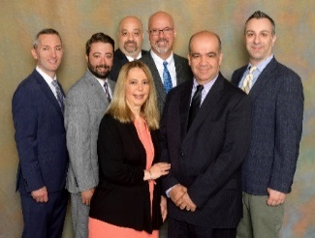
Maiorano & Associates, Inc.
Quarterly Newsletter July 2020
8754 Bay 16th St. Brooklyn NY 11214
P: 718-331-3700 F: 718-331-1290
Website: maioranotaxandfinancial.com

Quarterly Economic Update Second Quarter 2020
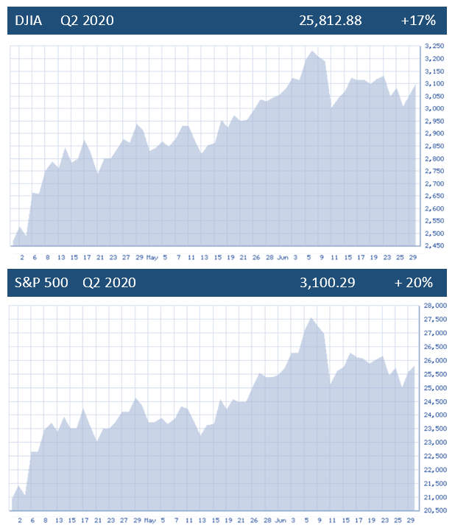

After a sharp waterfall drop in March, major equity markets advanced strong in the second quarter. Following the Dow Jones Industrial Average's (DJIA) worst first quarter ever, the index posted its best second quarter performance since 1938 rising over 17%. The S&P 500 ended the quarter up 20%, achieving its largest quarterly gain since 1998 and the best second quarter for blue-chip equities since the S&P 500 was created in 1957. While those indexes did not reach their earlier year highs, the Nasdaq Composite recorded all-time highs this quarter as technology stocks have largely emerged strong following their March fall. (Sources: Yahoo Finance 6/30/20, Barron’s 6/30/2020)
Although the equity markets posted gains this quarter, efforts to contain the coronavirus have had a major impact on the global economy. Most of the second quarter's stock-market advances took place in April and May. During June, the major indexes stayed in a relatively narrow range as investors evaluated increasing coronavirus cases against positive economic data.
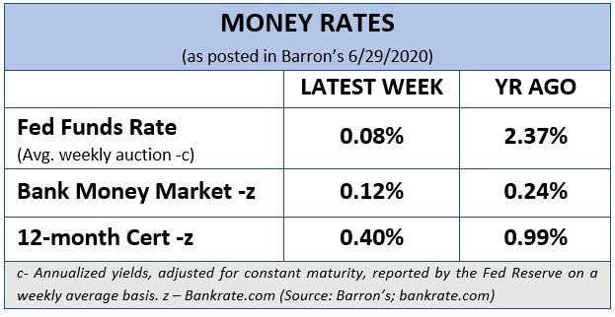
As equity indexes soared from their late-March lows, there was an incredible amount of data to digest including:
- bond yields remaining very low;
- gold prices rising to an eight-year high;
- unemployment skyrocketing to ultra-high levels;
- oil prices rebounding from Q1 lows (still down YTD);
- a Chinese survey showing factory activity rose to a three-month high in June; and,
- disease experts warning about losing control of the COVID-19 outbreak.
(Source: Market Watch 6/30/20)
It has been the best of times and the worst of times for U.S. equity benchmarks over the past two quarters. This could be why headlines are sharing that stock-market strategists have never been more confused in June about the year-end outlook for equities.
Key Points
- Equity markets surged in the second quarter.

- Interest rates are still in the spotlight as the Fed says they will keep rates low until the economy recovers.

- Unemployment numbers explode to over 20 million Americans.

- Economic uncertainty brings mixed opinions on recovery scenarios.

- Investors need to understand their time horizons.

- Now is the ideal time to revisit your personal objectives and the strategies to achieve them.

- Call us with any questions.

Investors this quarter enjoyed a nice rise in equity prices. However, with markets being heavily volatile, some analysts feel that the market may have moved too far, too fast and based on historical numbers, like price earnings, that equities are highly overvalued and overpriced. The other camp insists that we are still in a “TINA” market, meaning, There Is No Alternative to stocks. This group feels that with interest rates still near historic lows, that equities need to be an investor’s main position. Equities are not cheap and even the savviest of investors need to be considerate of risk.
We could devote many pages to all of the issues that need to be watched, but for the sake of brevity this quarterly update will focus on a few of the central themes for investors. As financial professionals, we assist clients by providing ideas and suggestions based on their risk tolerances and objectives. Our goal is to focus on each client’s timeframes and goals.
Interest Rates Are Still in the Spotlight

Changes in interest rates are important for investors to note because they can have both positive and negative effects on the markets. Central banks often move interest rates in response to economic activity. They historically have raised rates when the economy is overly strong and lowered rates when the economy is sluggish. The Federal Reserve (Fed) determines the United States rates at which banks borrow money. Their changes can produce a ripple effect across the entire economy. At their June meeting, the Federal Reserve kept interest rates near zero and indicated that’s where they’ll stay as the economy recovers from the coronavirus pandemic.
“We’re not thinking about raising rates,” Fed Chairman Jerome Powell said. “What we’re thinking about is providing support for the economy. We think this is going to take some time.” Central bankers also projected at the June session that the economy will shrink 6.5% in 2020. Then in 2021 they forecast a 5% gain, followed by 3.5% in 2022, both well above the economy’s longer-term trend.
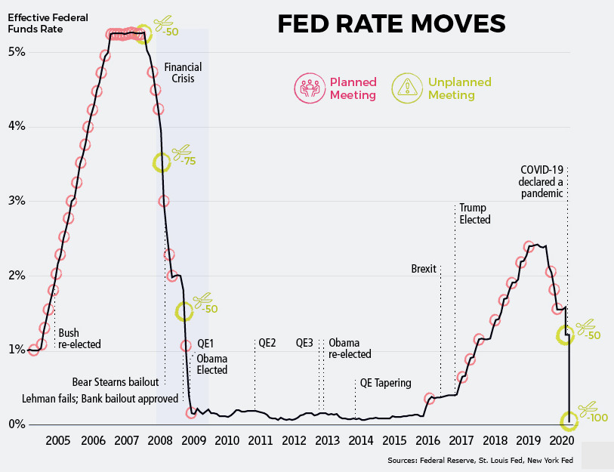
At the June session, Chairman Powell stressed that the pace of the recovery is dependent on the path of the coronavirus. The central bank repeated its commitment from the April meeting that it, “expects to maintain this target range until it is confident that the economy has weathered recent events and is on track to achieve its maximum employment and price stability goals.” Powell also said the Fed’s economic projections are based on “general expectation of an economic recovery beginning in the second half of this year and lasting over the next couple of years, supported by interest rates that remain at their current level near zero.” The Fed stated it will continue to increase its bond holdings, targeting large Treasury and mortgage-backed security purchases. Following that Fed meeting, markets reacted positively to the news. (Source: CNBC 6/10/2020)
Low interest rates can make the yields on bonds less attractive to investors that need and seek returns. With the Fed committed to keeping interest rates low for the foreseeable future, investors need to reexamine their portfolios and return expectations. Interest rates will continue to be towards the top of our “watch” list.

Unemployment

After several quarters of strong employment numbers, COVID-19 decimated the U.S. work scene. The COVID-19 outbreak and the economic downturn it caused increased the ranks of unemployed Americans by more than 14 million, from a historically low number of 6.2 million in February (a 3.8% rate) to 20.5 million in May 2020 (a 13% rate). The May numbers were the second highest since the 1940’s trailing only the level reached in April of this year (14.4%).

The rise in the number of unemployed workers due to COVID-19 is substantially greater than the increase experienced from the Great Recession. The Great Recession, which officially lasted from December 2007 to June 2009, pushed the unemployment rate to a peak of 10.6% in January 2010, considerably less than the rate currently, according to a new Pew Research Center analysis of government data.
(Source: Pew Research 6/11/2020)
Although the government, through programs like the Payment Protection Plan (PPP) have tried to save jobs, with many businesses closed or operating with restrictions, unemployment will continue to be an area that should be monitored by investors.
Economic and Political Concerns

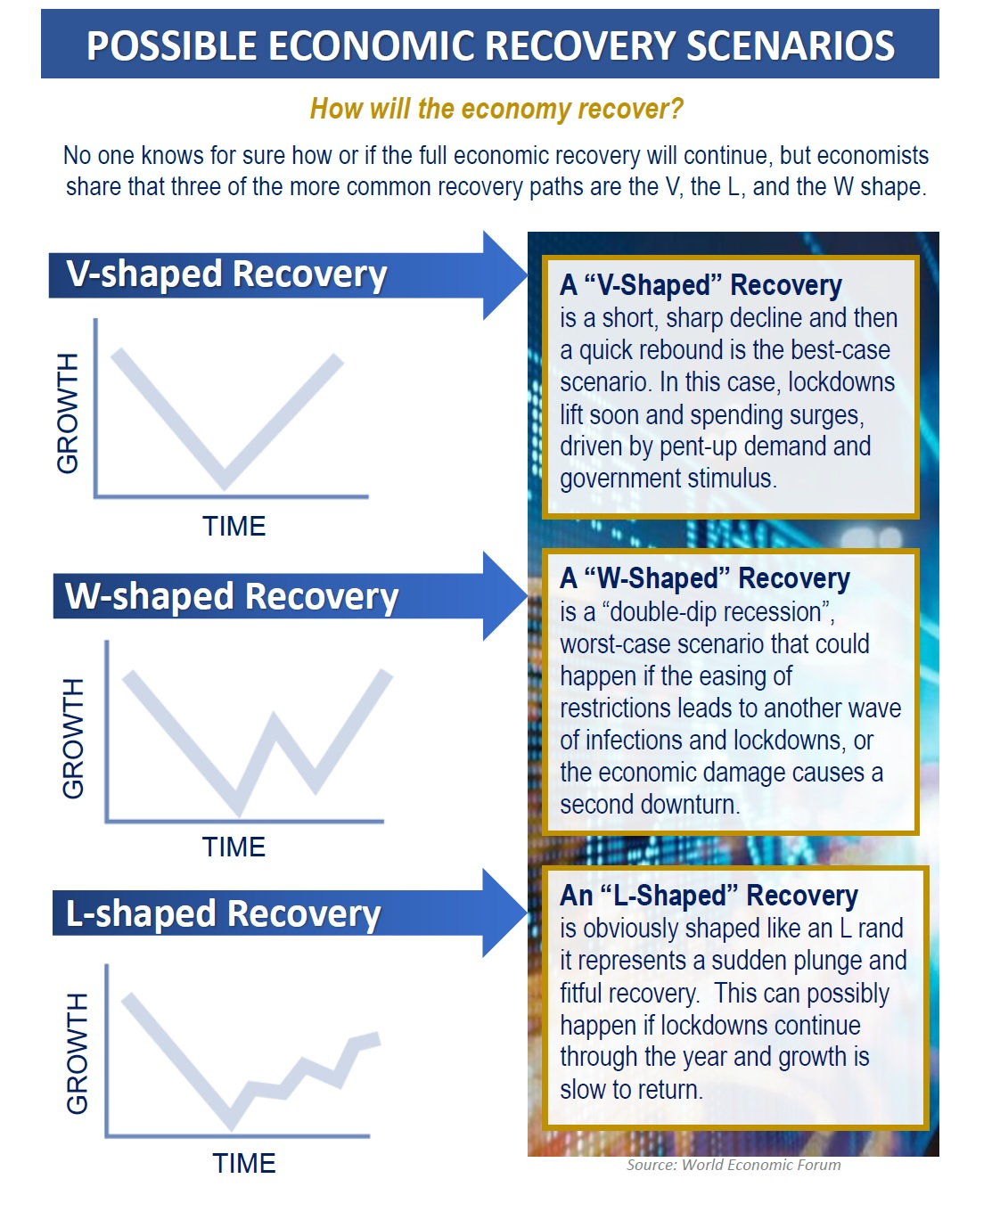
Equity markets enjoyed a strong quarter and have moved higher since their March lows. Equity markets typically lead the economy and one big unanswered question moving forward continues to be, how will the economy recover? The answer depends on who you ask. “The economy's turnaround from coronavirus-addled lows will arrive in the form of a steep V-shaped rebound”, according to Blackstone CEO Stephen Schwarzman.

He feels that we will see a two-stage recovery, with economic reopening sparking a rapid rebound from the bottom set in the second quarter. He also shares that, “Where the Federal Reserve's liquidity-boosting measures drove a sharp run-up for risk assets, easing of nationwide lockdowns will prompt a similar pattern for economic activity.” His advice to investors is, "You'll see a big V in terms of the economy going up for the next few months because it's been closed. As people are allowed to go back, the economy will really respond a lot." (Source:BusinessInsider.com 6/10/20)

JPMorgan strategists in their June message were less optimistic. They feel, “Investors should be more selective over the next six months as some assets will outperform others.” Their advice is that, “Investors should be more discerning over the next six months as markets are showing a ‘slight fatigue’."
(Source:BusinessInsider.com 6/10/20)
American Funds/Capital Group’s Vice Chairman and portfolio manager Rob Lovelace shares that, “it’s hard to predict the exact path of the recovery.” In their June mid-year outlook, he said, “It’s hard to know how wide the valley is, but I believe we will end up in a better place two years from now.”

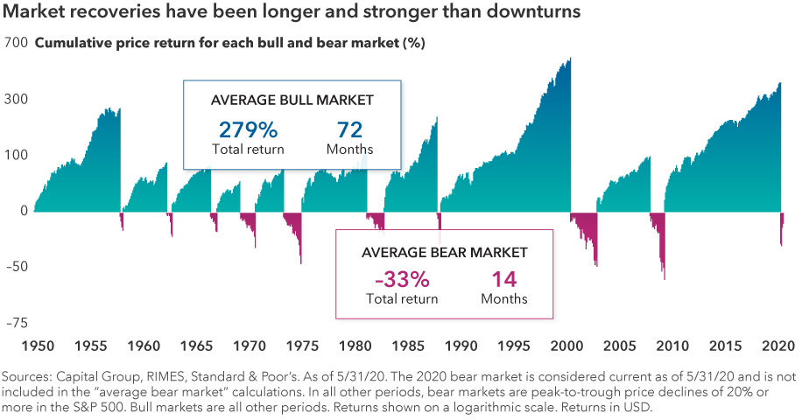
When sharing his economic outlook for the remainder of 2020, David Solomon, the CEO of Goldman Sachs said, “when you look at the initial shape of the recovery, which was preceded by a sharp decline in economic activity, it will start to look like a ‘V’ to begin with.” He stressed the "start" was the key aspect of that forecast. He added that, “Uncertainty still remains 6-12 months out and what additional negative impacts will result on the economy, including on the healthcare situation.” He expects the recovery to get more challenging and flatten out toward the end of the year and as we get into 2021. He noted it will take "quite a while" to get the economy back to where it started before the crisis.
(Sources: Capital Group 2020 Market Outlook 6/2020, SeekingAlpha.com 6/20/20)
As if the economy did not create enough concerns, political uncertainty (including the upcoming 2020 elections), continuing health concerns and social unrest are all additional areas we need to continually be aware of. From a financial standpoint, we try to understand how the political landscape affects investment markets. We will be keeping an eye on these activities and how it may affect your investments.
Strategies for Investors
During Market Volatility

Bear markets like the one we experienced this March can be confusing and painful. When investors suffer a sharp decline, it could feel like it’s never going to end. Any investor that panicked and sold their investments missed out on this quarter’s rebound. While prior equity market performance is no assurance of present performance, something to remember is that post-World War II, bull markets have been far more robust than bear markets, and they’ve lasted considerably longer. While every market decline is unique, over the past 70 years the average bear market has lasted 14 months and resulted in an average loss of 33%. By contrast, the average bull market has run for 72 months — or more than five times longer — and the average gain has been 279%. (Source: Capital Group 6/2020)

As investors learned in the last severe downturn, equity market returns have often been strongest right after the market bottoms. After the carnage of 2008, U.S. stocks finished 2009 with a 23% gain. Missing a bounce back can put an investor behind, which is why it’s important to consider staying invested through even the most difficult periods. Now is a good time to:

- Revisit your financial goals and objectives.
Investors should always put their primary focus on their own personal goals and objectives. When equity markets become volatile sometimes even the savviest of investors become not just concerned, but unnerved. It’s important to keep perspective when markets are volatile. It is very important that you understand your situation and your financial plan. Letting your emotions drive your decisions can be costly. A wise strategy is to proceed with caution and always allocate your investments to match your risk tolerance.
We focus on YOUR
personal goals and strategy.

Investor Outlook

The market responded well in the short-term to what looked like a successful reopening of the economy. Many analysts were amazed by the quick bounce-back in the market despite the enormous unemployment rate and the continuing bear market in the economy. While the fears of another downturn are real, investors need to understand, there is a major difference between a sharp selloff of 5%-10% and an over 30% decline like we suffered in March. Analysts feel that the public health situation and the economic landscape still present risk, so pullbacks in equity markets might even bring for some investors buying opportunities and not reasons to sell. Moving forward, an investor has to keep in mind that the fate of COVID-19 is still a gigantic unknown. It is impossible to predict if the first wave of impact is now calmed or if a second wave will emerge. Economic data will continue to be hard to forecast and equity markets are not always tied to economic data. During confusing and volatile times, it is always wise to have realistic time horizons and return expectations for your own personal situation and to adjust your investments accordingly. Three questions to ask are still:

Are you confident in your strategy?

Are you comfortable with your strategy?

Are you consistent with your strategy?

If you have carefully created a strategy with realistic financial goals, then try to not allow emotions or media magnification to influence you to shift from it.
Remember the words of legendary investor Benjamin Graham, Warren Buffett’s mentor.
“The best way to measure your investing success is not by whether you’re beating the market, but by whether you’ve put in place a financial plan and a behavioral discipline that are likely to get you where you want to go.”

A financial strategy is only as good as
your ability to consistently follow it.
We are here for you!
Our advice is not one-size-fits-all. We will always consider your feelings about risk and the markets and review your unique financial situation when making recommendations. If you would like to revisit your specific holdings or risk tolerance, please call our office or bring it up at our next scheduled meeting. If you ever have any concerns or questions, please contact us!
We pride ourselves in offering:

- consistent and strong communication,
- a schedule of regular client meetings, and
- continuing education for every member of our team on the issues that affect our clients.
A skilled financial advisor can help make your journey easier. Our goal is to understand our clients’ needs and then try to create a plan to address those needs.

Please share this report with others!
Our goal is to offer services to several other clients just like you! If you would like to share this article with a friend or colleague, please call Joanna McGuire at 718-331-3700. and we would be happy to assist you!

Securities and Investment Advisory services offered through Royal Alliance Associates, Inc. (RAA), member FINRA/SIPC. RAA is separately owned and other entities and/or marketing names, products or services referenced here are independent of RAA.

Note: The views stated in this letter are not necessarily the opinion of Royal Alliance Associates, Inc. (RAA) and should not be construed, directly or indirectly, as an offer to buy or sell any securities mentioned herein. Investors should be aware that there are risks inherent in all investments, such as fluctuations in investment principal. With any investment vehicle, past performance is not a guarantee of future results. Material discussed herewith is meant for general illustration and/or informational purposes only, please note that individual situations can vary. Therefore, the information should be relied upon when coordinated with individual professional advice. This material contains forward looking statements and projections. There are no guarantees that these results will be achieved. All indices referenced are unmanaged and cannot be invested into directly. Unmanaged index returns do not reflect fees, expenses, or sales charges. Index performance is not indicative of the performance of any investment. The S&P 500 is an unmanaged index of 500 widely held stocks that is general considered representative of the U.S. Stock market. Dow Jones Industrial Average (DJIA), commonly known as “The Dow” is an index representing 30 stock of companies maintained and reviewed by the editors of the Wall Street Journal. Past performance is no guarantee of future results. CD’s are FDIC Insured and offer a fixed rate of return if held to maturity. An investment in the Fund is not insured or guaranteed by the Federal Deposit Insurance Corporation or any other government agency. Although the Fund seeks to preserve the value of your investment at $1.00 per share, it is possible to lose money by investing in the Fund. Due to volatility within the markets mentioned, opinions are subject to change without notice. Information is based on sources believed to be reliable; however, their accuracy or completeness cannot be guaranteed.

Sources: Yahoo Finance, Barron’s, Market Watch, CNBC.com, Pew Research, Federal Reserve, World Economic Forum, BusinessInsider.com, Capital Group 2020 Market Outlook; SeekingAlpha.com, Contents provided by the Academy of Preferred Financial Advisors, 2020©

