Maiorano & Associates, Inc.
Quarterly Newsletter April 2020
8754 Bay 16th St. Brooklyn NY 11214
P: 718-331-3700 F: 718-331-1290
Website: maioranotaxandfinancial.com

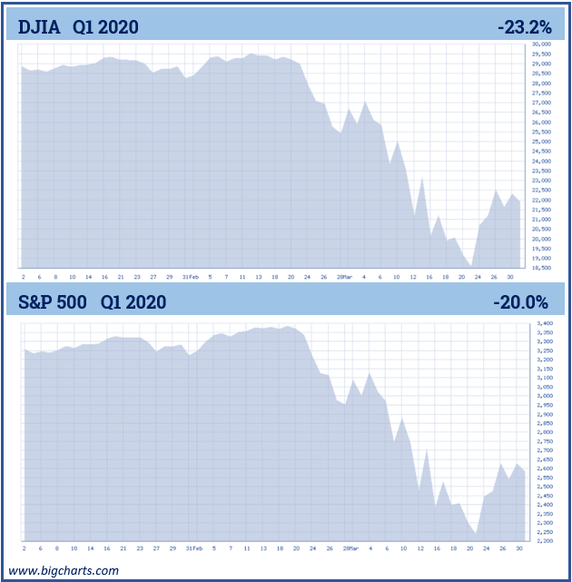
No one expected the longest bull market in history to see its demise brought on by a virus. While U.S. equity markets were able to withstand a trade war with China, a presidential impeachment, the potential for a global recession and global uncertainty including Brexit and civil wars in the Middle East, the U.S. economy was ambushed by a silent and highly contagious virus.

The first three months of 2020 were filled with Covid-19 fears and economic responses. The world is experiencing a pandemic and a financial crisis that caused many investors to feel a level of anxiety that they have not had for over a decade. It’s almost impossible to remember that in Mid-February, equity markets were experiencing all-time, record highs. Now, we are in an unprecedented, event-driven bear market. The intensity and extent of this crisis has been completely unpredictable. The health and financial crises are unchartered waters and the wake of the economic downturn created by Covid-19 will be seen for quite some time.
In the first quarter of 2020, more specifically, on March 12, the longest bull market in the history of the S&P 500 ended. This was the worst quarter for the Dow Jones Industrial Average (DJIA) since 1987 and its poorest first three-month start to the year on record.
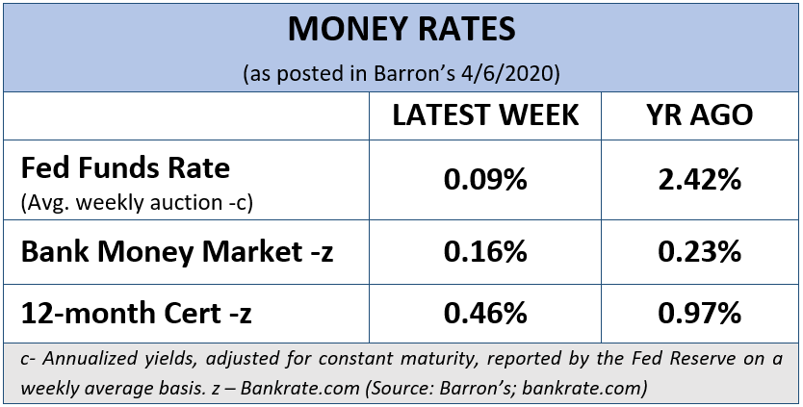
The Dow Jones Industrial Average’s decline of 23.2% for the quarter was its biggest since the 25.3% drop seen during the fourth quarter of 1987. The S&P 500 posted a 20% decline. Prior to this waterfall downturn, the stock market seemed unstoppable, with both the 122-year-old DJIA and the S&P 500 quadrupling earlier this year from their March 2009 lows. Many investors who remained vigilant and held their positions during that time were generously rewarded. Then, the bull market’s reign was abruptly ended with the COVID-19 pandemic. In just a few weeks, the stock market experienced several firsts in its history including:
- In less than three weeks, the S&P 500 fell from a 52-week high to a 52-week low.

- The Bloomberg Barclays U.S. Corporate Bond Index lost more than 7% in a week.

- The New York Stock Exchange (NYSE) experienced its worst set of down days where 90% or more of NYSE-traded stocks closed lower for the day.

- The S&P 500 hit the circuit breaker and triggered a trading halt four times.

- The Nasdaq Composite Index suffered its largest one-day percentage decline ever.

Key Points For Investors
1 | Your health is your first priority!
2 | Federal funds rates were reduced to  0 - 0.25%.
3 | Oil price wars between Saudi Arabia and Russia continue to affect equity markets.
4 | Government assistance was made available to help counteract the impact of this crisis.
5 | Covid-19 pandemic could have significant ripple effects on the global economy.
6 | Proceed with caution!
7 | We are now in a bear market, ending the longest bull market on record.
8 | Focus on your personal goals  and call us with any concerns.
- The Dow Jones Industrial Average posted its biggest weekly gain since 1938.
(Sources: marketwatch.com 3/16/20, WSJ 3/27/2020)

An 11-year bull market has changed into one of the quickest bear markets of all-times. The Covid-19 pandemic has presented the world with a situation that could not be remedied by monetary or fiscal policy. Not only is the world trying to stop the spread of a highly contagious virus, but it is also scrambling to fix the disruption of global supply chains and the decline of consumer dem

The U.S. government has been frantically making efforts to help ease the economic fallout from the pandemic through dramatic steps. These measures including the Fed dropping interest rates to zero and restarting the crisis-era program of quantitative easing by purchasing at least $700 billion in government and mortgage-related bonds. The Fed has also made it easier for banks to receive loans so they can in turn offer more business loans to small businesses and families in need. How long rates will stay at the 0 – 0.25% range is indefinite. In a statement by the central bank, “The Fed expects to maintain this target range until it is confident that the economy has weathered recent events.” Fed Chair Jerome Powell stated that, “The economic outlook is evolving on a daily basis and it really is depending heavily on the spread of the virus. That is just not something that is knowable.” (Source: washingtonpost.com, 3/15/20)

Interest Rates Are Still in the Spotlight

After lowering the federal funds rate by a half-point to a range of 1.0% to 1.25% in between its regularly scheduled meetings, as a response to the risks the COVID-19 coronavirus outbreak was creating, the Federal Reserve cut its benchmark interest rate in mid-March by a full 1% to 0%-0.25%. When the Fed first started reducing interest rates, many experts noted that the central bank was “catching up” to where markets had headed. Now, it seems as if they are responding to both the economy and the fact that the 10-year Treasury had fallen to all-time lows.

The all-time low for the Fed Funds Rate is effectively zero. The Fed has only lowered their rate to a range of 0% to 0.25% twice: once during the financial crisis of 2008 and now in March of 2020. After the first time, the Fed didn't start raising their rate until December 2015. Prior to 2008, the lowest fed funds rate was a range of 0.75% to 1.0% in 2003. (Source: TheBalance, 3/30/20)
CNBC reported on April 1st that the, “10-year Treasury yield falls to 0.6% as the coronavirus crisis deepens.” With interest rates at or near all-time lows, many investors cannot generate income or meet their long-term goals with a full portfolio of cash and bonds. (Source: CNBC, 4/1/20)
Oil Prices
Oil prices suffered an extremely rough stretch this quarter. As if things were not bad enough, the oil price war between Saudi Arabia and Russia, which emerged suddenly and dramatically on March 7, compounded the already ultra-bearish demand backdrop. The Saudi Arabia and Russia oil price war resulted in a massive price drop on March 8, 2020, when U.S. oil prices fell by 34% and crude oil fell by 26%. (Source: cnn.com; 3/8/2020)
A recent report from Barclays stated, “if the virus situation continues to worsen, as it has recently, oil prices could fall to the $10-15 range in the short term, barring a political intervention.” The report continued, “We estimate global available onshore crude storage capacity at about 1.5bn barrels, which could be overwhelmed in less than ten months with our oversupply estimate of over 5mb/d [million barrels a day] for 2020.” (Source: forbes.com, 3/24/20)
The Coronavirus’ impact on oil consumption is unlike anything in modern history. Governments continue to impose flight restrictions and other travel bans, enforce lockdowns, and require non-essential businesses to close doors. Numerous school closures also mean many fewer buses and cars will be on the roads. As the quarter closed, there was pressure on the president to step in and assist in resolving the price war. Oil prices saw the worst month and quarter in oil price history down over 50%. With energy companies and oil still being a contributing factor to the overall economy, oil prices are a topic we are keeping a watchful eye on. (Source: Washington Post, 4/2/20)
The CARES Act

The government is trying to help businesses and prevent the threat of a recession through the $2.2 trillion-dollar Coronavirus Aid, Relief, and Economic Security (CARES) Act. This emergency relief package, the largest economic-relief package in U.S. history, included:

- Extensions of unemployment benefits: Jobless claims will be available longer and benefits will be improved for four months. Furloughed workers and freelancers are also eligible.
- $150B for state and local governments.
- $500B in general corporate aid. $425B of that will be allocated by the Fed through loans to distressed companies. The other $75B is earmarked for hard-hit industries like travel and leisure.
- $350B in small-business loans that will be facilitated by community banks.
- $100B for the healthcare system.
- Direct payments to individuals: Individuals can receive up to a maximum of $1,200 per person ($2,400 per couple) depending upon their income.
The estimates for the total monetary and fiscal output to manage this crisis is $4 trillion, according to Jurrien Timmer, Director of Global Macro for Fidelity Management and Research Company. So far there has been a strong response from the U.S. government, which will need to take time to see if it produces results. (Source: fidelity.com, 3/23/20)
A Brief Lesson in Some Market Terms

Oftentimes, we hear the wrong words used in the wrong context. For educational purposes, we feel it is important to clarify some stock market words and their definitions.
“Dip” - a short-lived downturn from a sustained longer-term uptrend.
Example: Equity markets increased by 5% and maintained that level and then dipped back down to 3% all within a few days or weeks.
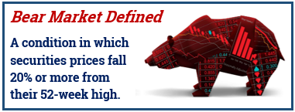
“Correction” - a 10% drop in the market from recent highs. Historically corrections occur an average of about every eight to 12 months and last about 54 days. (thebalance.com 3/9/20)
Example: On December 17, 2018, both the DJIA and the S&P 500 dropped over 10% and declines continued into early January.
“Bear Market” - a long, sustained decline in the stock market. If the market declines 20% from the its recent high, this is considered the start of a bear market.
Example: On Wednesday, March 11, 2020, The DJIA dropped 5.9%, for a total decline of 20.2% from a record high on February 12, 2020.
“Crash” - a sudden and dramatic drop in stock prices, often on a single day or week. Crashes are rare, but typically happen after a long-term uptrend in the market.
Example: In 1929 the market crashed when it lost 48% in less than two months, ushering in the Great Depression.
Bear Market Basics
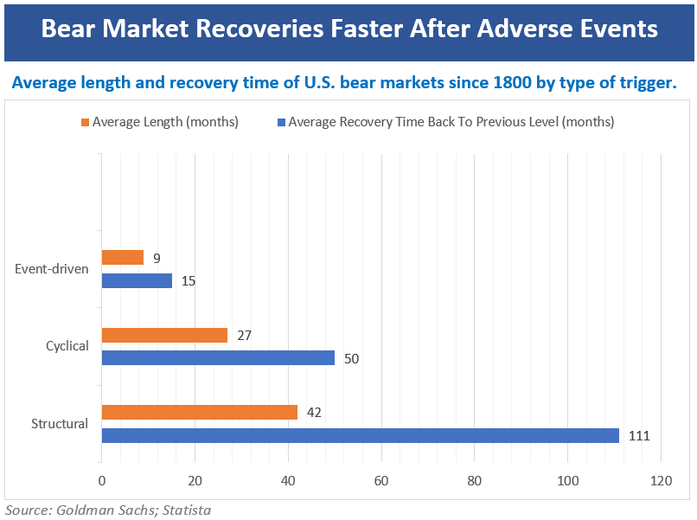
Bear Market’s Most Basic Principle: Bear markets are a part of the investing experience.
The bear can show its face even during times of a bull market. Many people believe that a bull market means a steady growth in equities. This is not the case. During this most recent, long-standing bull market, there were 13 corrections and the market moved down intraday into bear market territory (down at least 20%) three times. (Source: www.fidelity.com)
We have now entered into a bear market territory (a close of 20% down) so it might be helpful to review some information about bear markets.
Bear markets can be classified into one of three categories: structural; cyclical; and event-driven.
Goldman Sachs analyzed bear markets back to 1835. They defined these three markets as follows:
- Structural: bear markets created by imbalances and financial bubbles, very often followed by a price shock such as deflation. The markets have an average drop of 57%.

- Cyclical: bear markets that are typically a function of the economic cycle, marked by rising interest rates, impending recessions and falls in profits. These markets have an average drop of 31%.

- Event-driven: bear markets created by events such as war, an oil price shock, an emerging-market crisis, or like most recently, a sudden viral pandemic (Covid-19).
We are currently in an “event-driven” bear market. These are the bear markets that are hardest if not impossible to forecast or navigate. Covid-19 created a first of its kind bear market, one that was caused by a virus. We have had event-driven bear markets, but none were created by a viral pandemic. According to Goldman Sachs Chief Global Equity Strategist Peter Oppenheimer, “event-driven ” bear markets, on average, result in lower declines than the other two types, and historically have lasted shorter. This unusual downturn is one that offers no easy outcomes. (Source: marketwatch.com 3/11/20)

How should investors think about this downturn and what should they do?

Investors generally hope that equity markets will go up. The volatility and turbulence of this current economic and political environment has caused even some of the most seasoned investors to become skittish. In March, legendary investor Warren Buffett said that he hadn’t seen anything like the coronavirus pandemic. “If you stick around long enough, you’ll see everything in markets,” he told Yahoo Finance. “And it may have taken me to 89 years of age to throw this one into the experience.”

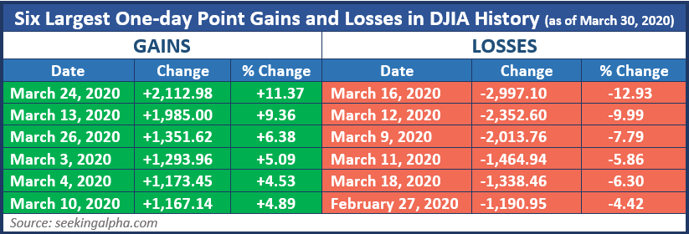
Since that statement, it’s become even more confusing as infections mount around the world and the stock market continues to spin out of control in both directions. Many investors are trying to compare their portfolio’s performance during this difficult period. So how did the Berkshire Hathaway leader perform?
“While Buffett is well known for weathering the worst market downturns and coming out stronger, the last several weeks have been just as painful on his portfolio as it has on the broader market,” Bespoke explained in a post noting that the average stocks in his top holdings on March 24th were down 37% from their February highs. Perhaps the most important thing to think about is that like everybody else, his portfolio obviously hasn’t been immune to all this volatility. (Source: MarketWatch.com, 3/27/20)
The chart in this report shares that the six biggest point declines and the six biggest point increases in the Dow Jones Industrial Average (DJIA) all came in the last five weeks of this quarter. On March 12th, the DJIA fell 2,352 points which was over 9%. Had you sold that day you missed the next day’s (March 13th) rise of 1,985, also a move of over 9%. This level of volatility is unprecedented and therefore even the savviest of investors needs to PROCEED WITH CAUTION!

Helpful Strategies for Investors
Revisit Your Personal Objectives
First and foremost, we continue to urge you to ask yourself four questions:

- Have my financial timelines changed?
- Have my financial goals changed?
- Has my risk tolerance changed?
- Are there any changes my advisor needs to know about my situation?
As always, your main focus should be on your own personal objectives, regardless of whether or not the market environment is up or down.
Riding out a bear market can be easier for those who have a diversified portfolio that is consistent with their overall plan, including their time horizon, financial situation, and risk tolerance. If you’d like to revisit any of these areas, please let us know and we will be happy to discuss these with you.

Think Long-Term
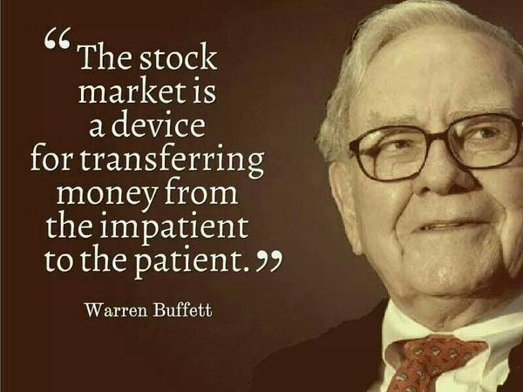
We are watching this crisis carefully and want to take a moment to remind you that long term investors will experience volatility and periods of uncertainty. Invest for the long term, especially when you have an opportunity to acquire investments at attractive valuations, keeping in mind that there is no assurance when (or if) these investments will advance. Today’s low valuations reflect the high uncertainty expected in the near future. Many economists and money managers, however, are not as concerned about the next 5 or 10 years. Investing involves uncertainty and no one can guarantee that market volatility will lessen or stabilize over the next 5-10 years.

Look Into Rebalancing
Maintaining a properly designed and well-diversified portfolio is important. Now is a good time to take a look at your portfolio and consider any rebalancing that may need to be performed. For many investors who had a 60/40% stock to bond portfolio a few months ago, this percentage may have changed in the past few weeks.
Suspend Distributions
Some investors may not need to take distributions from their accounts at this time. If you are comfortable with suspending distributions and looking for a potentially better time to take them, please call us at we can see if this strategy works for your personal situation.
Consider Roth IRA Conversions
There are many reasons to consider Roth IRA conversions. Depending on who wins the presidential election this year, or how much the government injects into their stimulus, there is a chance that for some investors, tax brackets may rise. Also, for many retirement accounts with equities, account values are down. This can create opportunities, especially for those investors currently in the 12%, 22% and 24% tax brackets. Add in the new SECURE Act’s changes to inherited IRAs and it becomes even more prudent to consider the pros and cons of a Roth IRA conversion. Roth Conversions have some complicated rules and guidelines, therefore, as always, first discuss this option with us and your tax preparer to see if they are a good fit for your financial goals.
Think Rationally, Not Emotionally
One of Sir John Templeton’s “Rule’s for Investment Success” is, “Do not be fearful or negative too often.” Market turbulence should remind us that it is a good idea to re-evaluate instead of panic. Revisiting your current financial situation and evaluating that your risk tolerance, goals and needs are still congruent with your time horizon is a wise plan of action. We will, of course, be doing this at your next review, but if you feel you would like to do this sooner, do not hesitate to call us.
Tune Out Media Magnification
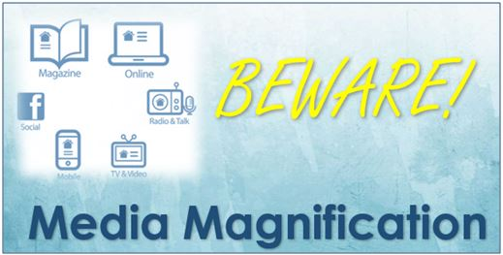
It can be difficult to make rational investment decisions when the markets are fluctuating. It can be even harder with the doom-and-gloom headlines that dominate the media. Fear sells, and everywhere you look, the media magnification of the current financial crisis is putting a major emotional strain on most viewers. During these times, it is prudent to resist the temptation of watching news reports and obsessively watching portfolio performance. Sometimes, the more information you have, the more likely you could make a decision that deviates from your long-term strategy. Adhering to a long-term investment plan often requires taking the news with a grain of salt and putting the impromptu advice of others on the back burner.
Avoid Herd Mentality
A powerful influence to avoid is the herd mentality. Especially in today’s easy access to information through multitudes of news sources and media outlets, one can be easily influenced by potentially misleading information and actions, and thus abandon reason and simply follow the crowd. Once you are aware of this pitfall, it is important to avoid it and remain focused on executing an investing strategy that is most appropriate for your situation.
Being prepared for any future circumstances that may arise and staying the course for your personal investment goals are key to long-term financial security. Sometimes this can be easier said than done especially during volatile times when external influences are at a peak.
Seek the Help of a Professional
One of our primary goals is to make sure you are comfortable with your investments. Peaks and valleys have always been a part of financial markets. Even if your time horizons are long, you most likely have experienced, and will continue to experience, some short-term movements in your portfolios. Rather than focusing on the turbulence, you will want to make sure you have a diversified investing plan that is focused on your personal goals and timelines.
We will always consider your feelings about risk and the markets and review your unique financial situation when making recommendations.
We pride ourselves in offering:
- consistent and strong communication,
- a schedule of regular client meetings, and
- continuing education for every member of our team on the issues that affect our clients.
A skilled financial professional can help make your journey easier. Our goal is to understand our clients’ needs and then try to create a plan to address those needs.
We care about our clients and we are here for you. Our goal is to be prepared, not scared! If you feel we need to talk, please call. We are honored that you have chosen us to help with your financial needs.
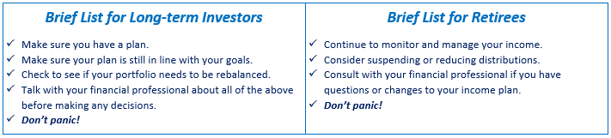
As stewards of your wealth, our primary goal is to align your investments to your time horizons and risk tolerance. Please stay positive and try not to get too immersed in the day to day rollercoaster ride we call the stock market! We appreciate the confidence you have in our firm.
Please share this report with others!
Our goal is to offer services to several other clients just like you! If you would like to share this article with a friend or colleague, please call Joanna at Maiorano & Associates at 718-331-3700 and we would be happy to assist you!

Securities and investment advisory services offered through Royal Alliance Associates, Inc. (RAA), member FINRA/SIPC. RAA is separately owned and other entities and/or marketing names, products or services referenced here are independent of RAA.

Note: The views stated in this letter are not necessarily the opinion of Royal Alliance Associates, Inc and should not be construed, directly or indirectly, as an offer to buy or sell any securities mentioned herein. Investors should be aware that there are risks inherent in all investments, such as fluctuations in investment principal. With any investment vehicle, past performance is not a guarantee of future results. Material discussed herewith is meant for general illustration and/or informational purposes only, please note that individual situations can vary. Therefore, the information should be relied upon when coordinated with individual professional advice. This material contains forward looking statements and projections. There are no guarantees that these results will be achieved.
All indices referenced are unmanaged and cannot be invested into directly. Unmanaged index returns do not reflect fees, expenses, or sales charges. Index performance is not indicative of the performance of any investment. The S&P 500 is an unmanaged index of 500 widely held stocks that is generally considered representative of the U.S. Stock market. Dow Jones Industrial Average (DJIA), commonly known as “The Dow” is an index representing 30 stock of companies maintained and reviewed by the editors of the Wall Street Journal.
Diversification is used to help manage investment risk; it does not guarantee a profit or protect against investment loss. Rebalancing a portfolio may cause investors to incur tax liabilities and/or transaction costs and does not assure a profit or protect against a loss.
Due to volatility within the markets mentioned, opinions are subject to change without notice. Information is based on sources believed to be reliable; however, their accuracy or completeness cannot be guaranteed. International investing involves special risks, including currency fluctuations, differing financial accounting standards, and possible political and economic volatility. Investing in emerging markets can be riskier than investing in well-established foreign markets. Investing involves risk and investors may incur a profit or a loss. Sources: Barron’s, marketwatch.com; washingtonpost.com; goldmansachs.com; politio.com; fidelity.com; cnn.com; forbes.com. Contents provided by the Academy of Preferred Financial Advisors, Inc.
“The first wealth is HEALTH.” – Ralph Waldo Emerson

COVID-19 Stimulus Bills Six Key Takeaways
There are three bills enacted to help mitigate the economic impact of the Coronavirus pandemic: The Families First Coronavirus Response Act; The Coronavirus Preparedness and Response Supplemental Appropriations Act; and the Coronavirus Aid, Relief, and Economic Security (CARES) Act. Here are six key takeaways from these bills we feel may be of primary importance to our clients.

- New Income Tax Filing Dates - The deadline for filing 2019 income tax returns is now July 15, 2020. The deadline for making 2019 IRA and HSA contributions has thus also moved to July 15, 2020. Deadlines for contributions to workplace savings plans have not changed. Please check with your state for any changes to state filing deadlines.

- Required Minimum Distributions - The required minimum distributions (RMDs) for 2020 on some retirement accounts has been waived. For more specifics on your account, please call us.

- Direct Payments – The CARES Act included a provision that will send $1,200 to most Americans with income under $75,000 and $2,400 for joint filers under $150,000. This amount will reduce for people with higher incomes and become zero at income levels of $99,000 for individuals and $198,000 for couples. You can also receive up to $500 per dependent child ($3,400 maximum).

- 10% Early Withdrawal Penalty Waived for Workplace Retirement Plans - Those with workplace retirement plans and individual retirement accounts (IRAs) can take aggregate distributions of up to $100,000 for COVID-19-related purposes without incurring the 10% early withdrawal penalty. Those who chose to take an early distribution still have to pay federal income tax on the distribution but can spread it over a 3-year period or they have the option to repay the distribution within a 3-year period back to an eligible retirement plan.
- Student Loan Aid – Provisions have been made to help those with student loans. These provisions include suspended payments of federal student loans for six months and waiving interest on the loans for six months.

- Small Business Relief - $350 billion has been allocated to help small businesses through the crisis and keep their workers employed. Known as the Paycheck Protection Program, federally guaranteed loans will help many small businesses during this time of crisis.
This is for educational purposes only. Please talk with your tax preparer about your specific situation.

Could it get worse, or will it get better? How long will this last?

We know these are many investors primary questions. A large part of the answers will depend on when the growth rate of Covid-19 cases stabilizes and how quickly a cure can be developed and distributed. It will also depend on whether or not fiscal and monetary emergency measures are enough to help ease the economic crisis. While we are not clairvoyant, we are making our best efforts to stay aware of changes that could affect your personal situation. Our objective is to try to offer the most educated guidance to help keep you on track with your financial goals. We realize that this is a very emotionally straining time and we want to make sure you know we are here for you. Call us with any questions or help with any concerns you may have.

Panic and bad choices can cause more harm for investors than a virus or market downturn!

