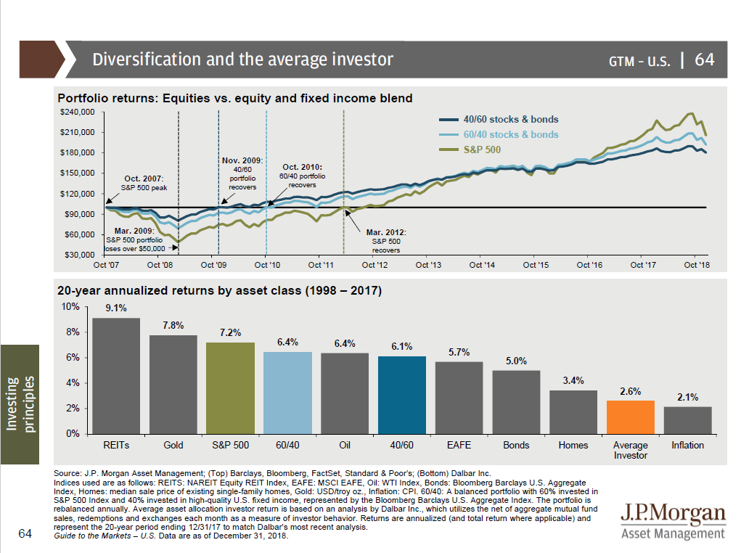

Predicting the Future is Hard
The Wall Street Journal recently shared a graphic showing predictions from 50 economists on the direction of interest rates. The average forecast for the end of June was 3.39% on the ten-year.
As you can see in the chart below, not one of the predictions came close to where rates currently are. -from David Perell

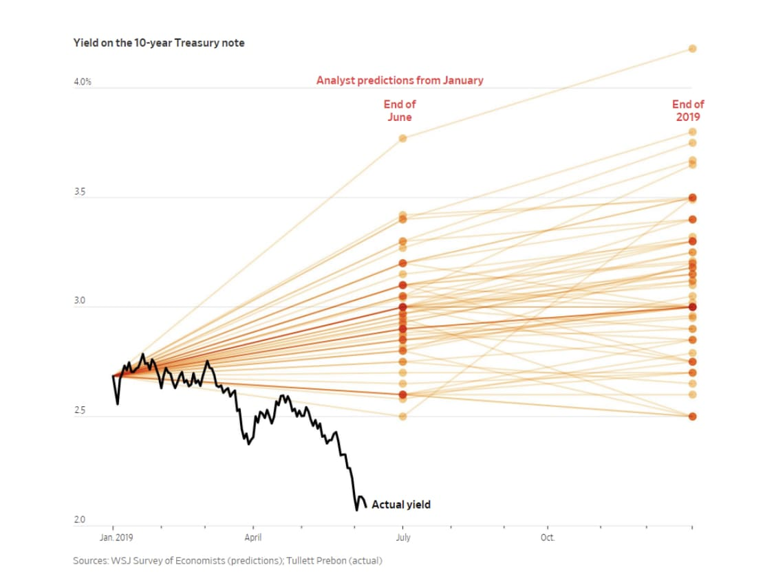

Geographic Arbitrage

Where you live can make a large difference in your lifestyle expenses as well as how much wealth you can accumulate. This chart is from Jim Dahle MD, and compares the average home price vs. income for a family practice physician in many US cities.

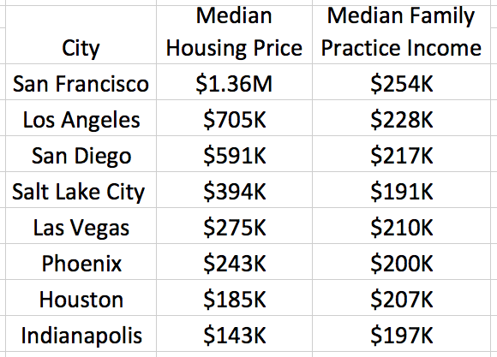

The Benefits of Industrialization and Capitalism

It is noteworthy that income growth over the last two centuries went hand in hand with other salutary developments.
As late as 1870, life expectancy in Europe, the Americas, and the world was 36, 35, and 30 years. Today, it is 81, 79, and 72 years.
In 1820, 90 percent of humanity lived in extreme poverty. Today, less than 10 percent does.
In 1800, 88 percent of the world’s population was illiterate. Today, 13 percent of the world’s population is illiterate.
In 1800, 43 percent of children died before their fifth birthday. Today, less than 4 percent does.
In 1816, 0.87 percent of the world’s population lived in a democracy. In 2015, 56 percent did.
In 1800, food supply per person per day in France, which was one of the most advanced countries in the world, was a mere 1,846 calories. In 2013, food supply per person per day in Africa, the world’s poorest continent, amounted to 2,624 calories.
Conflict, which was the default state of humanity for millennia, has declined. In the early 1800s, the combined military and civilian death rate from conflicts was about 65 per 100,000 people. By 2000 that rate had fallen to about two per 100,000. The last great-power conflict, which pitted China against the United States over the future of the Korean Peninsula, ended in 1953.
Slavery, which was rampant in most parts of the world in 1800, is now illegal in every country.
4
Finally, for the first time since the start of industrialization, global inequality is declining as developing countries catch up with the developed world. Between 1990 and 2017, argues Branko Milanovic from City University of New York, the global Gini coefficient, which measures income inequality among all of the world’s inhabitants, decreased from 0.7 to 0.63.
Marion Tupy in National Review

How Much Interest Are You Getting on that CD?

It may be hard to believe, but most European government bonds now have negative interest rates. Yes, that means you pay them to hold your money in a presumably safe place. Here is the yields on Swiss government bonds. You pay them almost 1% of your funds annually for a one to five year bond. The Swiss government does not pay you interest until you lend them money for forty years, at which point they pay you under one tenth of one percent per year. Can this happen in the US? Ten year US bonds are at 2% and the Federal Reserve is set to cut rates further. At Wealth Care LLC, we continue to try to find reasonable returns on fixed income globally.

