Wealth Care LLC February 2026 Commentary

Investment Thoughts

We’ve discussed why we diversify in these commentaries before. Basically, it is because we do not know in advance which global asset classes (stocks) will do well at any one time. We have just had a very nice run up in US stocks for the last decade, and now – under the radar- foreign stocks are far outpacing their US counterparts. Good to own both. In the first decade of this century, foreign stocks also far outpaced US stocks (as the US had the two brutal bear markets of 2000 and 2008). Then, from 2010-almost now, the US was the place to be—possibly due to almost zero percent interest rates (and subsequent inflation). Now, with “normal” type interest rates, the US stock market is puttering along, driven by just a few large tech stocks, which foreign stocks are widely moving up from “cheap” valuations. There is no way to predict when these moves occur, and keeping a portfolio from the wide swings in value when concentrated in one place is essential to long term success.

Returns this year: US stocks +18% International stocks +30% US bonds +7%

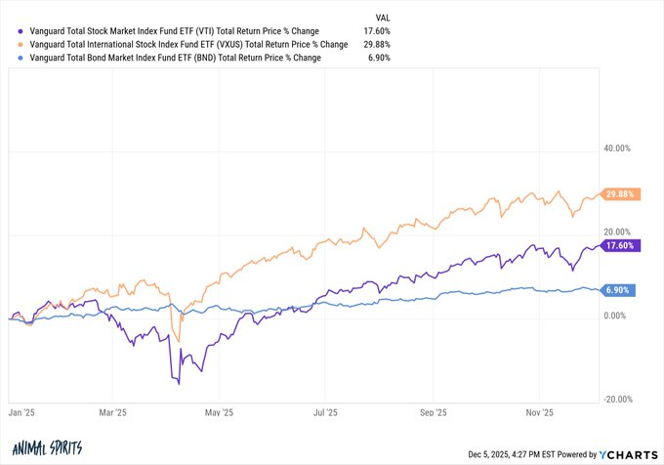

Look at these 2025 results—who could predict that Europe and Emerging Markets would far outpace our own S&P 500? Again, for the long term investor-good to own both.

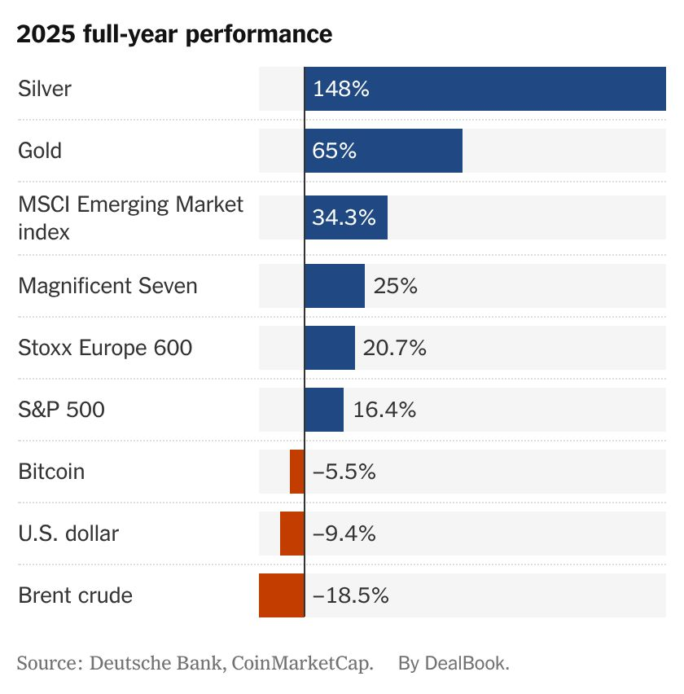

The chart below was designed to illustrate that having a “balanced portfolio of roughly 60% invested in stocks and 40% in fixed income/bonds has done relatively well for decades with only rare significant downdrafts. But there are a couple of other interesting things to take out of it. First, who remembers the almost 20% drop in prices just four years ago? It was one of the very few times that both stocks and bonds dropped a lot in price at the same time (bonds dropped when interest rates went from almost zero to 4% in a short time and inflation was high). And it was the worst time for this “conservative” asset allocation since the 1930s!
The second thing to remember is not illustrated here, which is that over long periods of time, having less fixed income means higher returns.

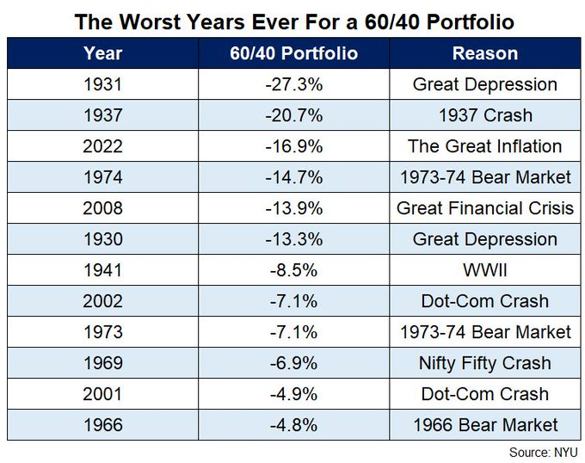

Watching your portfolio closely is unwise:

How often does stock market decline?
1% drop: 50-60 times a year
3% drop: 7-8 times a year
5% drop: 3-4 times a year
10% drop: every 1.1 years
15% drop: every 2 years
20% drop: every 3 ½ years
25% drop: every 5-7 years
(S&P 500 avg since 1928)

Understanding the New Trump Accounts

You must have a child under 18 years old
You will be eligible to register at trumpaccounts.gov later this year—but can put your name on a mailing list now. The election to establish an initial Trump Account is made on IRS Form 4547 or through the online tool available at trumpaccounts.gov.
You can get $1,000 for every American child born between January 1, 2025 and December 31, 2028 from the government. You may also deposit up to $5000 a year in after tax funds which will grow tax free until withdrawn.
Much more detail is expected and we will keep you updated.

If You Made Charitable Contributions from an IRA:

Until 2025, if you made charitable contributions from your IRA (only possible starting in the year you turn 70 ½), Fidelity and other custodians would not report it separately and you might be stuck paying tax on those contributions. However starting with the tax forms you will get soon, reporting has changed.

QCD (Qualified Charitable Distribution) reporting involves receiving an IRS Form 1099-R from your IRA custodian and then correctly reporting the distribution on your Form 1040. For 2025, custodians are required to use a new Code Y in Box 7 of Form 1099-R to identify QCDs, though for 2025 reporting, this is optional. The taxpayer then excludes the QCD amount from their gross income, and it is not reported as a tax deduction.
What to do
- Receive Form 1099-R:
Get IRS Form 1099-R from your IRA custodian. It will likely have the new Code Y in Box 7 to indicate a QCD.
• • Report on your tax return:
On your Form 1040, report the QCD distribution but ensure the amount is excluded from your gross income. You do not report it as an itemized deduction.

Required Minimum Distributions

There are frequent and understandable questions about just when we must begin taking taxable distributions from our retirement accounts. These are called Required Minimum Distributions (RMDs). For most of us, if we are born before 1960, we must begin to take our RMD in the year we turn 73. The exception to this is that if we are still working in a company we (or our spouse) do not own-we can postpone RMDs from that specific work 401k plan (not old plans or IRAs) until the year we stop working. For those born in 1960 or after, the RMDs begin in the year we turn 75.

We can delay the first RMD until April 1 of the following year but you must then take two RMDs in that year. RMDs start in the 4-5% (of account value on the last day of the prior year) range and slowly increase with aging. You can always take out more than the RMD but not less.

Any amount of your RMD that goes directly to charity (called a Qualified Charitable Distribution) is not considered as taxable income to you (discussed in another place).

Private Credit

We are seeing a flood of articles about and offers to invest in “private credit.” It is accurate to think of private credit as non-bank lending. So, funds are raised by various entities (read investors) and lent to a variety of borrowers such private equity funds that were unable to offload some of the companies they purchased, private real estate ventures, and more. These loans have highly variable security and are usually opaque to the “investor.” They offer higher promised interest rates as the attraction for investing in their products and often offer large commissions to the salespeople pushing their products. We are very wary of these investments in all but the highest quality and are avoiding them in general. They are often illiquid as well (hard to get your money back when you want it) and you are unlikely to be compensated for that.

Miscellaneous

Time feels different at 52 than at 25. My kids don’t need help tying their shoes anymore. There’s a quiet shift when you realize you’ve gone from being their entire world to becoming a chapter in their expanding life. My father passed away a few years ago. My mom passed when I was eleven. I live with the unfortunate truth of knowing exactly how many more moments I’ll have with them, and the number is zero. I’d trade everything I’ve earned for one more hour with them. Seneca said, "Life isn’t short, we just waste it." I’ve wasted plenty. I’ve rushed when I should have slowed down. I’ve attended meetings that drained life instead of adding value. I’ve said yes when I should have kindly said no. Marcus Aurelius said: “You could leave life right now.” One day you’ll wake up for the last time and not know it. That doesn’t depress me. It sharpens me. It brings everything into focus. Mortality shows up quietly: a child outgrowing a phase, laughter at the dinner table evolving into deeper conversations, friends moving away as life reshuffles itself, opportunities you once assumed would always be there slowly fading. I’m not trying to optimize every second. That’s a stress trap. I’m choosing what matters. If I don’t want to spend time with someone, I don’t. If something drains me, I drop it. If I’m tired, I rest. If one of my kids wants to talk, I close the laptop. When I care, I go deep. And here’s the upside: when I spend time with someone, they know I truly want to be there. I show up with more presence, more patience, more warmth. I connect more honestly. I feel more like myself because everything I’m doing is aligned with who I choose to be. I’m living by design, not by inertia. I’ve lost money. I’ve made bad decisions. Money is replaceable, time isn’t. Many people talk about urgency and clarity that mortality brings. My perspective is different: don’t treat time as a motivator — use it as a filter. If I had ten good years left instead of forty, I wouldn’t retreat from life. I’d let go of more nonsense. I’d keep fewer grudges. I’d be slower to irritation and quicker to laughter. Mortality is a filter. It quietly asks: Is this how you want to spend today? Is this conversation worth having? Is this relationship worth nurturing? Is this work worthy of your life-force? I’ve had the very human misfortune of attending many funerals over the years. Don’t wait for tragedy to wake you up to what you already know. The reminders are around you: in your relationships, your aging body, your memories, the irreplaceable moments that slip by unless you notice them. “You have two lives, and your second life starts when you realize you only have one.” – Confucius
-Vitaly Katnelson

People are living​ longer than they used to. They are also having fewer children. The evidence of what this combination can do to a society is growing around the world, but some of the most striking stories come from Japan. For decades the Japanese health ministry has released an annual tally of citizens aged one hundred or over. This year the number of centenarians reached very nearly a hundred thousand. When the survey started in 1963, there were just 153. In 1981 there were a thousand; in 1998 ten thousand. Japan now produces more nappies for incontinent adults than for infants. There is a burgeoning industry for the cleaning and fumigating of apartments in which elderly Japanese citizens have died and been left undiscovered for weeks, months or years. Older people have far fewer younger people to take care of them or even to notice their non-existence. That neglect is a brute function of some simple math. In 1950, Japan had a Total Fertility Rate (TFR) of 4, which represents the average number of children a woman might expect to have in her lifetime. Continued over five generations, that would mean a ratio of 256 great-great-grandchildren to every sixteen great-great-grandparents – in other words, each hundred-year-old might have sixteen direct descendants competing to look after them. Today Japan’s TFR is approaching 1: one child per woman (or one per couple, half a child each). That pattern continued over five generations means that each solitary infant has as many as sixteen great-great-grandparents vying for his or her attention. Within a century the pyramid of human obligation has been turned on its head. (Source: lrb.co.uk)

Digital passport
You can add a US passport as your digital ID to your wallet app on an iPhone running iOS 26.1 or later. You still need to carry your passport overseas, but you can pull out this ID for TSA clearance at 250 airports in the U.S., including SFO, LAX, JFK and LGA. To do this go to your wallet, hit the + in the upper right, then choose “Driver’s License and ID Cards,” then “Digital ID.” You’ll be prompted to hold your phone’s camera over the photo page of your passport and then you need to touch your phone to the chip embedded in the back of the passport. Then you’ll be asked to take a selfie and do some prescribed head movements to verify you are real. Finally, your application will await verification. Once verified (mine took only a few minutes) your passport ID will appear in your wallet. — KK

Protect Your Access-a good article from the Wall Street Journal

How to Avoid Getting Locked Out of Your Digital Life

Passwords are forgotten, phones get lost. But there are steps you can take to ensure you never lose access to your email, apps, cloud storage and more by Sean Captain
What would happen if you couldn’t access your Apple, Microsoft or Google account because you lost your phone, forgot your password or were hacked?
Since so much of our digital lives resides in just a few places, getting locked out of critical accounts such as these, even for a few hours, can halt your ability to email, check calendars or work on documents.
Redundancy—such as backing up passwords and setting up alternate ways to access your accounts—is your best protection against such disasters. And companies like Apple, Microsoft and Google offer many tools to help you avoid losing access to their services.
Here are some of the best strategies you can use to ensure you always get into your critical accounts:

Use a password manager
The easiest way to keep from getting locked out of an account is to set up and use a password manager. It can be the free one built into your browser (such as Chrome’s Google Password Manager) or your device’s operating system (such as Apple Passwords), or an independent free or paid app like Bitwarden, 1Password or Dashlane. The latter type offers the best compatibility across web browsers and operating systems.
These managers generate robust passwords, then store and automatically enter them (and your username) whenever you want to sign into a website or open an app that requires a login.
Unlike scribbles on a Post-it note, a password manager can be set to back up online. That means if you lose your phone or computer, you can sign into the password manager on another device—either yours or someone else’s—and access the backed-up passwords for your accounts from there.
Of course, to do this, you will need to remember the master password that unlocks the password manager or have another way to access it. For more on that, see below.

Set up passkeys
If one of your accounts offers you a new sign-in option called a passkey, be sure to enable it, as it will give you an alternate way to log in, one that doesn’t require typing in a password. (Apple, Google and Microsoft will all nudge you to do this and guide you through the process on their sites.)
Passkeys authenticate your identity using a pair of mathematically related values, called keys, one residing with the website or app, the other in your password manager. Typically, you authorize this exchange with a face scan, fingerprint reader or a PIN code if your device doesn’t support those biometric options.
Passkeys are convenient and more secure than passwords, which can fall into the hands of criminals during data breaches. And if you log in with a passkey instead of a password, sites typically won’t ask you for a second level of identity verification, such as a two-factor authentication code sent to your phone. That can come in handy if you lose your phone or lose access to your phone number in a hack.

Provide more than one contact email or phone number
Most sites offer an “I forgot my password” button on their login pages for users who can’t remember their credentials. It usually triggers an email or text to the user with instructions on how to reset the password.
But what if you can’t access the email because you’re locked out of the account? Or the phone number on file has been taken over by crooks? To ensure you won’t miss that message, most accounts allow—and encourage—you to register a second email address and/or one or more recovery phone numbers.
You can easily create a second email for yourself using free services such as Gmail, Outlook or Yahoo. You also can create a second phone number that can be accessed online or in mobile apps, through services such as the free Google Voice.

Designate other people as recovery contacts
If a site or app lets you designate adult friends or family members as trusted recovery contacts, be sure to do it. These people won’t have access to your account, but they can help verify your identity so you can regain access should you get locked out.
Google, for example, allows you to designate up to 10 people (with a Google account) for this purpose. During the recovery process, Google will send three codes to your contact person and one to you. You tell your recovery contact the code you received, and the recovery contact has to select it from the three he or she received to unlock your account.
Apple offers a similar system, supporting up to five contacts. But they must have an Apple device to generate a recovery code, which they then give to you. Microsoft says it’s considering creating its own trusted-contacts system.

Install mobile apps
Consider downloading any mobile apps associated with your big accounts—such as the Gmail or YouTube app if you use Google—because some sites allow you to prove your identity that way. If you have trouble logging into your Google account on a web browser, for example, you may be instructed to open one of those mobile apps. When you do, a screen will ask if it is you trying to log in to your account. The benefit here is that you are typically always logged in to apps on your mobile device.
Microsoft provides a similar capability with its Authenticator app, which some people use for two-factor authentication in place of texted codes for signing into online accounts. Apple allows people to reset their passwords using a Mac, iPhone, iPad or Vision Pro headset if they are already logged into one of them.

Ensure access to your password manager
Advertisement
If you’re using a password manager for password and passkey generation and storage, it’s crucial that you don’t lose or forget the master password that unlocks it—and that you set up an alternative method to get back in if you do.
Start by devising a complex yet easy-to-remember password, perhaps a nonsensical but memorable passphrase.
As insurance in case you forget it, you can record the master password on an unlabeled sheet of paper and store it somewhere secure—a safe, if you have it, or at least not out in the open.
You also can use a second password manager to store the login for your main password manager. If you use Dashlane, for instance, you can log into Dashlane via the Google Chrome browser, and have Chrome store the Dashlane password.
In some cases, you may be able to get into your password manager with a fingerprint or face scan, if you’ve set that up. And some password managers allow you to set up recovery contacts, or shared access to an account, that can help you get back in should you forget the master password.
Random Notes

Lack of appreciation is where relationships go to die. Vocalize appreciation in the moment—write it down, say it out loud, tell the person what you love about them. Applies to family, friends, and romantic partners.-Sahil Bloom

The highest form of wealth is deciding you have enough.-Kevin Kelley
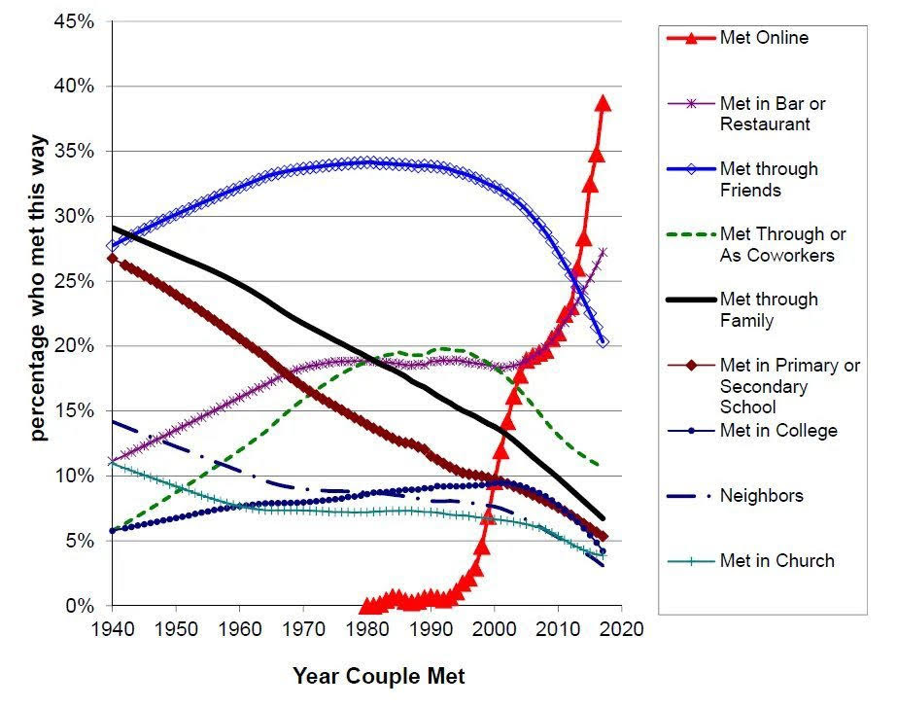

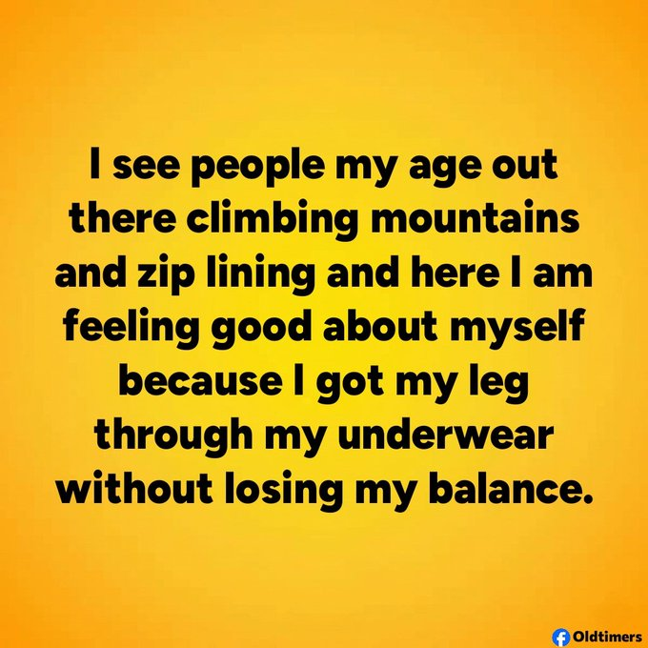



From the Wealth Care LLC Team February 1, 2026

