Wealth Care LLC October 2019 Commentary

Investment Thoughts
Investment returns through August for the last decade by year:

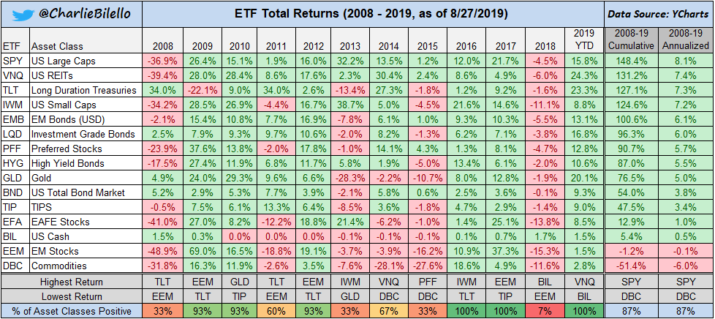

So far, in 2019 we are seeing the best performance in large cap US stocks and in interest sensitive securities (long term bonds and REITs).

A Reminder on Normal Volatility:

S&P 500 stats from 1946 – 2014:
177 declines of 5% or more, or every 5 months
55 declines of 10% or more, or every 1.25 years
21 declines of 15% or more, or every 3.25 years
12 declines of 20% or more, or every 5.75 years

Catch a Falling Knife -or The Dangers of Owning Individual Stocks

Wow. Look at the price of JC Penney stock in late August. Sixty one cents and heading for bankruptcy. Note it was almost 100X higher just a few years ago. We can find dozens of articles in the last five years proclaiming the company was “turning around”, and a “great value.” The losses of owning such a stock in a non diversified portfolio would more than wipe out the typical gains from several other “winners”.

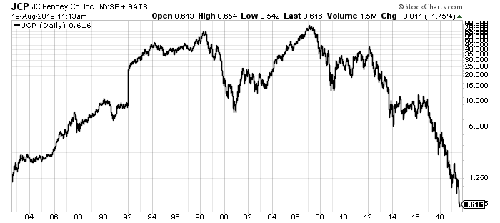

What’s on Sale Today?
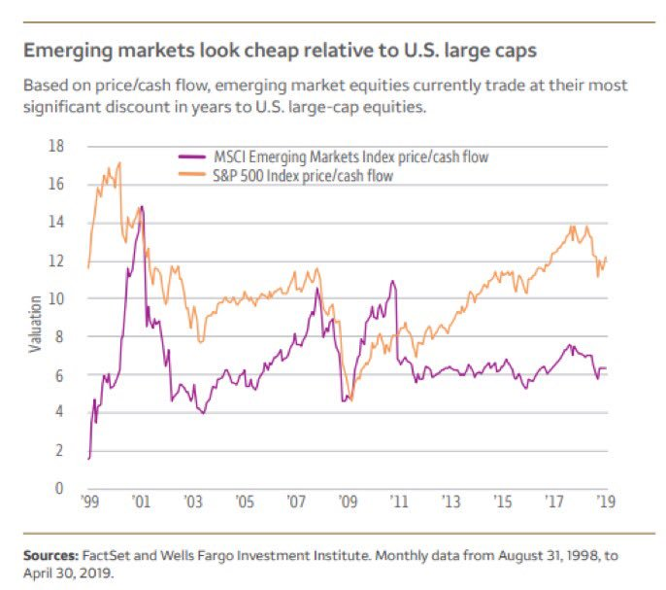

Miscellaneous

Mortgage Refinance

Interest rates are historically low out to thirty years. If you have a mortgage that is not close to ending with an interest rate over 4%, talk to us about a loan modification or refinance.

Minimum Wage Arguments:

Almost nobody earns the minimum wage in this country. Average wages in September came in at over $22 an hour, and the following chart shows what a “non-issue” this topic is.

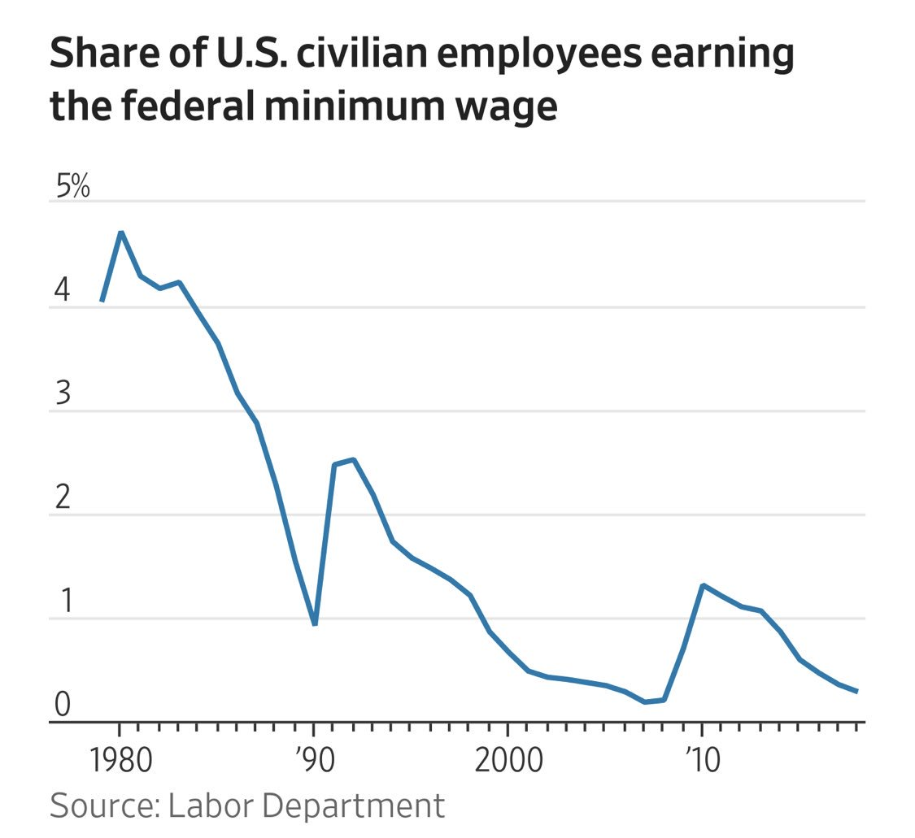
Anti-Aging and Longevity

Through a physician friend, I’ve developed an interest in keeping up with the science of why we age, and perhaps how to even reverse some of the negative effects of aging. The amount of good information is exploding. My personal beliefs after reading extensively is that the following behavior has no harm and leads to a healthier longer life for most:
Have a lean body weight
Don’t smoke
Do regular resistance training (weights usually) at least a couple of times a week-consider doing some high intensity work also (get your heart rate up)
Eat a low carb diet (especially simple carbs like sugars). Avoid most vegetable oils.
Consider a 12 hour or more period on most days with no food (I skip breakfast)
Moderate amounts of alcohol might help.

Beyond these behaviors, the rest is experimental-but very interesting. One source of information that I enjoy and think is reputable is a (free) newsletter and podcasts by Peter Attia MD (https://peterattiamd.com/). Steve

Random Notes

“Some say the glass is half-full. Some say half-empty. I say the glass is too big”
— George Carlin
Investing should be more like watching paint dry or watching grass grow. If you want excitement, take $800 and go to Las Vegas. --Paul Samuelson
Success is walking from failure to failure with no loss of enthusiasm. --Winston Churchill
The Stock Market is designed to transfer money from the Active to the Patient. --Warren Buffett

