Wealth Care LLC January 2026 Commentary

Happy New Year!!!!!!!!!

Patience Rewarded

Look at the returns of various markets all just during 2025! April brought fear of upcoming tariffs and caused marked selling and lower prices. For example, you can see the S&P 500 had dropped 15% year to date (blue bar) by April. But if you did nothing but wait, the next bar (orange) revealed the same index UP almost 18% by October 27. Those that sold their stocks in April-ouch. The recurrent message is that stocks are volatile, and we must be disciplined and patient to capture the superior gains they will give us.

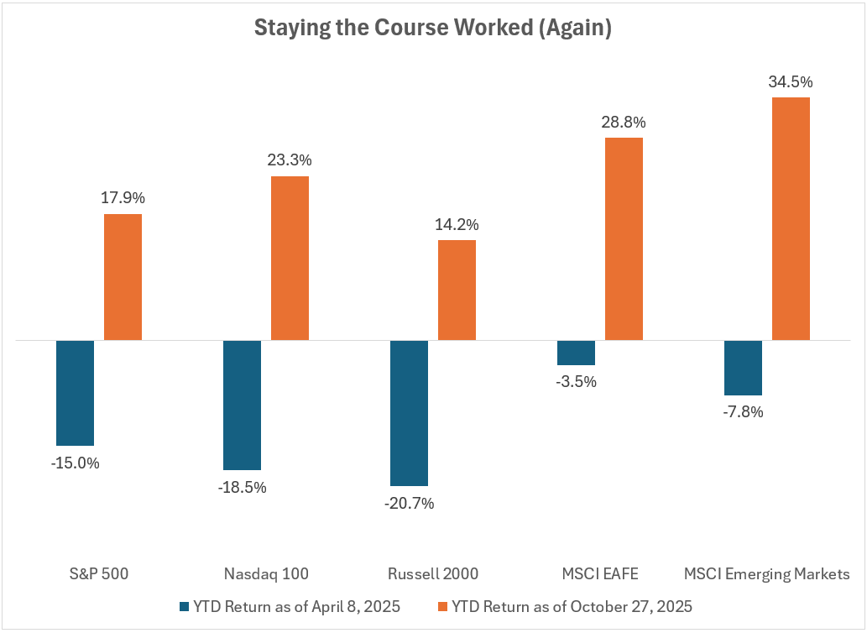

More History—here are the returns if you patiently held the largest US stock index over various decades. Not bad. And as noted here recently, international stocks are doing even better than US stocks for the calendar year.
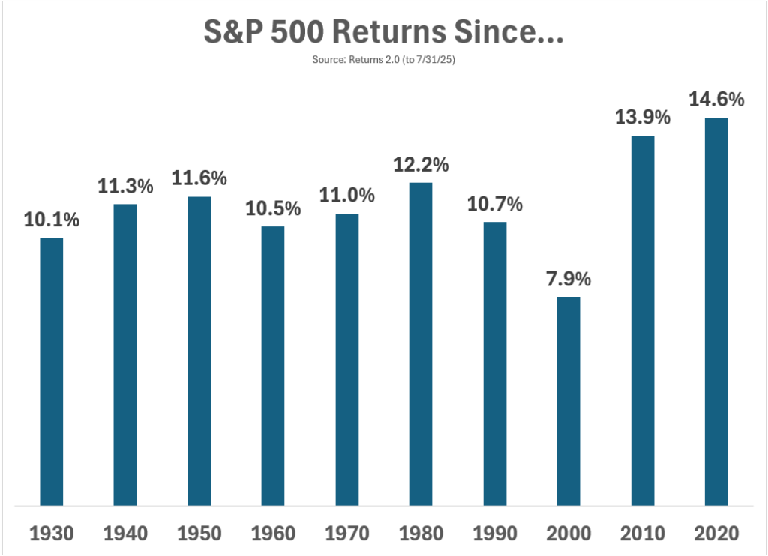

It’s Gold!

There has been a lot of financial press about how well Gold is doing. We are mostly ambivalent about owning gold, and do not include it in most portfolios. But, we are happy to include it for those that want it. It has not been a great inflation hedge and has sorely underperformed traditional equity investments. See the charts below---gold has had a 40 year bear market

compared to the S&P 500, only rising in the last year or so. 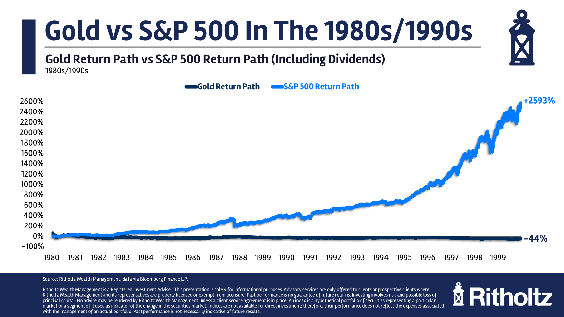

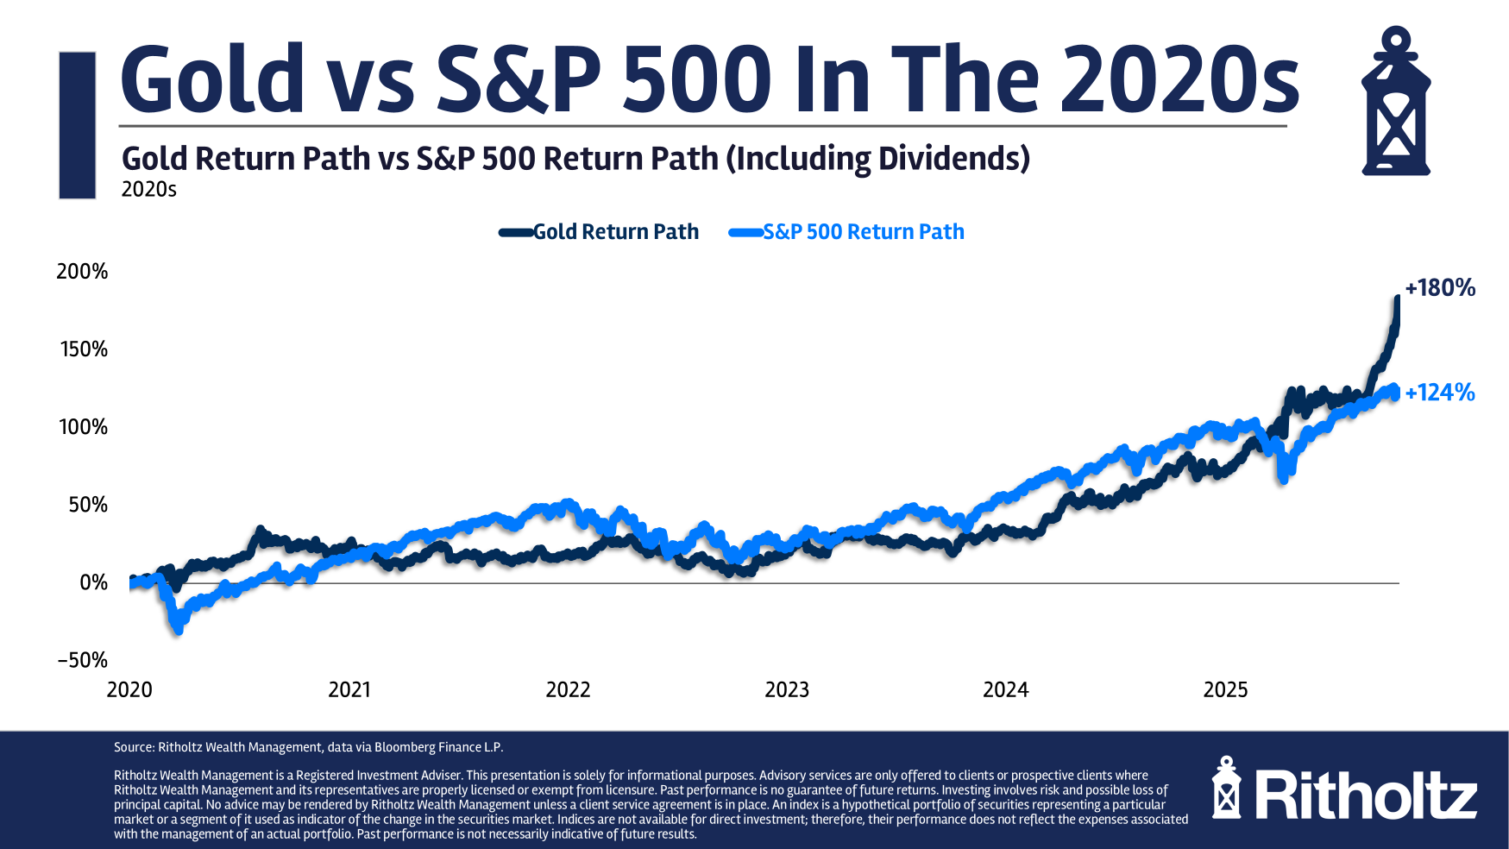

New Charitable Deduction

To date, charitable donations are a “Schedule A” deduction which most of you do not use unless your property taxes, mortgage interest, and charitable contributions combined exceed (for couples) 31,000 dollars (the standard deduction). Beginning in 2026, a couple may make up to $2000 in cash (checks/credit cards are fine) donations to charity and take a full deduction regardless of income (or anything else).

Miscellaneous

Scientists have identified five major “epochs” of human brain development in one of the most comprehensive studies to date of how neural wiring changes from infancy to old age. The study, based on the brain scans of nearly 4,000 people aged under one to 90, mapped neural connections and how they evolve during our lives. This revealed five broad phases, split up by four pivotal “turning points” in which brain organization moves on to a different trajectory, at around the ages of nine, 32, 66 and 83 years. “Looking back, many of us feel our lives have been characterised by different phases. It turns out that brains also go through these eras,” said Prof Duncan Astle, a researcher in neuro-informatics at Cambridge University and senior author of the study. “Understanding that the brain’s structural journey is not a question of steady progression, but rather one of a few major turning points, will help us identify when and how its wiring is vulnerable to disruption.” (Sources: theguardian.com, nature.com)

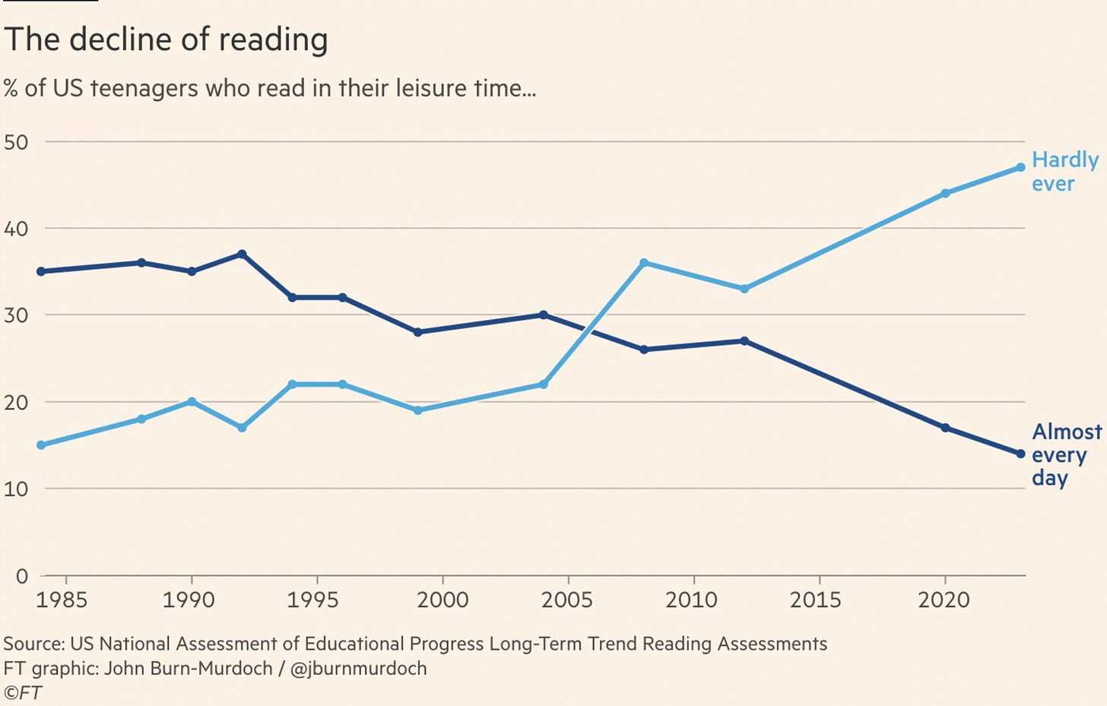

I really liked this:

The Relationship between time and money
Jared Dillian
You’re having a cookout, so you go to the store to buy some burgers. You have a choice:
· A big lump of ground beef
· A package of eight pre-made burgers
How you answer this question says everything about you and your outlook on life.
So I actually asked AI about this. AI probably rolled its eyes when it got the search query. “How much does ground beef cost versus pre-made burgers?”
- Ground beef: $6.50 per pound makes 4 quarter-pound burgers, so each patty costs about $1.63.
- Pre-made/fresh patties: At $6.49–$7.50 per pound, each 4 oz patty costs $1.62–$1.88.
- Bulk frozen patties: Often about $1.47 per patty, sometimes slightly less per pound in very large packs.
So you’re saving, at most, 25 cents per burger by buying the big lump of ground beef? Multiplied by eight burgers is $2.00? Brilliant!
So then you have to consider how much time it is going to take to take that big lump of ground beef and turn it into burgers. Let’s say, for the sake of argument, 15 minutes, which means that you’re valuing your time at $8/hour, which is just above the federal minimum wage (which nobody makes anymore). Also, you get burger fat all over your hands, and no matter how hard you try, and how many times you wash your hands, your hands are going to smell like burger for the rest of the day. And you make a mess of your kitchen.
The fact is that humans are not meant to make burgers out of ground beef—machines are. Machines will do it better and cheaper. Also, the burgers you make yourself will be all lumpy and they’ll fall apart on the grill. The pre-made burgers you get from the grocery store are perfect.
So sure, if you want to save two bucks, make the burgers yourself, in your million-dollar house and with your $80,000 car in the garage. If you buy the lump of ground beef 40,000 times, you will have saved enough for a new car. Maybe you just like the feeling of meat in your hands. You can come over to my house anytime.
A few years back, Mr. Money Mustache did a blog post about how he made a pizza at home to save money. A pizza from Domino’s was $20, and the ingredients to make a pizza were $5, so he saved $15. Brilliant!
Except making your own pizza is a pretty labor-intensive proposition, so you’re spending three hours rolling out dough and chopping vegetables and grating cheese and making sauce, so if you value your time at $25/hour, it’s an $80 pizza. $5 for the ingredients and $75 for the labor. Again, Domino’s makes pizzas faster and better than you—they have what’s known as economies of scale, so you should just order the pizza from Domino’s and do whatever you want to do with your free time, like watch baseball, or write a blog post, or whatever. Another concept worth talking about here is the division of labor—you’re really good at trading stocks, and someone else is really good at making pizza, so you should trade the stocks and let someone else make the pizza. I suppose if you thought having a pizza night at the house was a good thing to do with the family, then sure, you can justify this behavior, but you’re not saving any money.
Time is more important than money. You can always make more money, but you can’t make more time. I’ll say that again—you can’t make more time. The 15 minutes you spend pounding ground beef you will never get back—you are 15 minutes closer to death. Now, let’s say that you were very, very poor. Indigent, even. Then, it would make sense to buy the lump of ground beef and make burgers. But for everyone else, making your own burgers is a money-losing proposition.
I will tell you a story. When I moved into my last house in 2015, the first day I was in the neighborhood—we were still moving in furniture—two cops showed up at the front door. They asked if I had seen anything unusual in the neighborhood. Apparently, there was a burglar going around stealing TVs in the middle of the night. Well, the guy eventually got caught. Now, in the universe of TV burglars, this guy gets the gold medal. He broke into 24 houses and stole 24 TVs before he got caught, which is an excellent record. And then I thought about it—what was he selling the TVs for? Probably $300 at most. And he couldn’t sell them all at the same pawn shop—he was probably driving all over the state to move the hot TVs. If you took into account all the nights he spent breaking into houses, and all the time he spent trying to move the hot TVs, it probably came out to about $15 an hour. And he ended up getting an eight-year sentence.
Which brings me to my point—for normal people, good people, they understand the relationship between time and money. Criminals don’t. Criminals will risk 20 years in prison for $20. You know who else doesn’t understand the relationship between time and money? Cheapskates. Your landscaping bill is $300/month. I’m not paying that, that’s outrageous, and then you do your own landscaping, which values your time at $10/hour. I suppose some people like doing their own landscaping—they enjoy getting all hot and sweaty, but as a way to save, it is a money-losing proposition. Again, the landscaping company has economies of scale, and there is such a thing as a division of labor, so if you make $30/hour uploading fart videos to YouTube, then it makes sense to do fart videos and let someone else do the landscaping.
I think about this all the time, and it is to the point where if I am walking through the grocery store parking lot and I see a nickel on the ground, it actually doesn’t make sense for me to pick it up, because it takes me five seconds to stop and pick it up, and I make more than a nickel every five seconds. It probably doesn’t make sense for me to pick up a quarter, either. Inevitably, I do, because I abhor waste, but it makes no economic sense. And it’s about time that we got rid of the penny. All that time wasted counting out pennies at McDonald’s drive-thrus. Forget the penny, round up to a quarter, and make the line move 20% faster. The whole change thing is funny—there’s been so much inflation that some places I go (even gas stations) will just round up or down to the nearest dollar. Forget the shrapnel. For my part, I take all my change and put it in a jar and take it to Coinstar once a year and get about $150 in cash, which is the most efficient way to deal with change.
Washing your car? Run it through the car wash. Cleaning your house? Hire housekeepers. Painting a room? Hire a painter. Doing home repairs? Hire a handyman. You’re going to be standing on the top step of a ladder changing a light bulb and fall and end up in the hospital breathing out of a hose. The car wash does it better and faster. The housekeepers do it better and faster. The painters do it better and faster. Some people do have a psychological need to control this stuff—I do it better. At what cost? Since we moved into the new house, we have landscapers ($475/month), housekeepers ($440/month) and we have never been happier. And I do realize that some people like washing their own cars. Put on the Bluetooth speaker, listen to some tunes…yeah, I don’t get it. Run it through the machine for $12 and save two hours. Literally anything else would be a better use of your time. I spent about five hours today working on my novel, not sitting on a riding mower with a can of Busch Light and a toothpick sticking out of my mouth.
They say time is money. Time is more than money. I don’t want to spend one second of my time doing something I don’t want to do. If that means I spent an entire afternoon vegging out and watching baseball, that is better than the alternative. I work, make money, and spend it on time-saving help and inventions. Easy for me to say, right? Freaking rich guy. Actually, these principles apply to pretty much everyone. A lot of people think they’re poor, when they’re really not. Buy the pre-made burgers for the first time in your life, and see the difference.

--------------------------------------------------------------------------------------------------------
Random Notes

The CEO of Bronco Wine – which sells the Charles Shaw “Two Buck Chuck” wine at Trader Joe’s – was once asked how he’s able to sell wine for less than the cost of bottled water.
He replied: “They’re overcharging you for the water. Don’t you get it?

“The world of pregnancy is going to radically change, predicts Noor Siddiqui. “I think that the default way people are going to choose to have kids is via IVF and embryo screening,” she said at the WIRED Health summit last week. “There’s just a massive amount of risk that you can take off of the table.” Siddiqui is the founder and CEO of Orchid, a biotech company that offers whole-genome screening of embryos for IVF. By analyzing the DNA of different embryos before selecting which one to implant, Orchid says, parents can lower the risk their children grow up affected by conditions with a genetic basis. Siddiqui was speaking with George Church—a pioneer in genomics and a professor of genetics at Harvard Medical School—at the summit in Boston, exploring the promise and potential of whole-genome sequencing. An estimated 4 percent of people worldwide have a disease that’s caused by a single genetic mutation. With embryo screening, “these monogenic diseases can be just completely avoided,” Siddiqui said. On top of this, roughly half the world’s population suffers from a chronic disease with at least some genetic basis. Analyze five embryos ahead of implanting one, Siddiqui said, and ‘you can now mitigate the genetic component of that risk by these double-digit numbers. You’re talking about in the worst case 30 percent and in the best case up to 80 percent.’” (Sources: wired.com, linkedin.com, orchidhealth.com, wyss.harvard.edu, sciencedirect.com. Italics mine.)

Make your eulogy more important than your resume. -David Brooks




The Wealth Care LLC Team January 1, 2026

