Wealth Care LLC November 2019 Commentary

Investment Thoughts
We Have Negative Interest Rates in the US
I’ve commented on the fact that most of the developed world outside of the US has negative interest rates-that is, you pay to keep your money on deposit. In the US, we have positive interest rates-that is you get back a little more money by lending it to others. But if you are lending money to the US Government by investing in bonds (perhaps the biggest bond market there is), you are really paying to lend that money. Why? Because buying (lending to the government) a ten year bond pays 1.8% interest, and even lending for 30 years pays 2.2%. If we accept that inflation runs 3% a year (which it has for over fifty years on average), we get less money back in terms of purchasing power than we started with. It’s all relative.
The Global Economy is Expanding
The nice chart below shows a steady growth of the world’s economies. Owning global stocks lets us share in this increasing wealth.
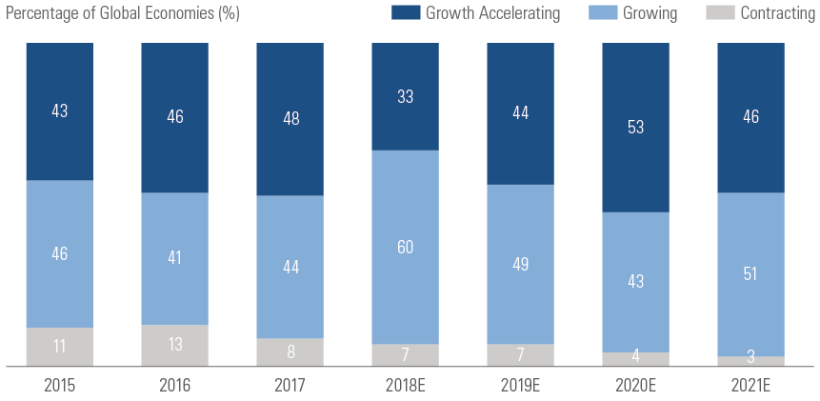

Which Countries Will Lead the Way in This Expanding Growth?

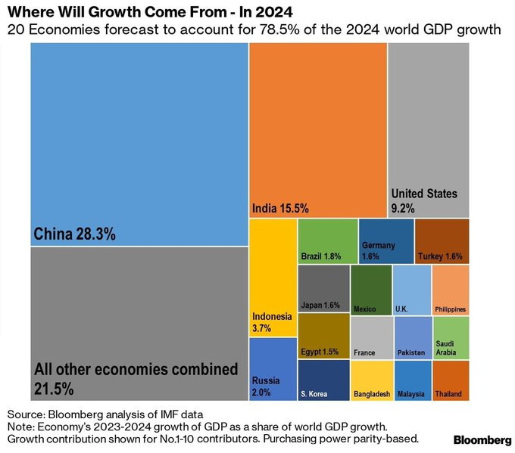

Why Own the Market Instead of Individual Stocks

The chart below is a nice illustration of the odds against picking individual companies that will have stock prices increase by more than the broad US market over a 34 year period. Only a handful out of many thousands of companies appreciate more than the broad index of the entire US market during this period. Do you think you (or anyone else) can pick those few “winners” out of the crowd?
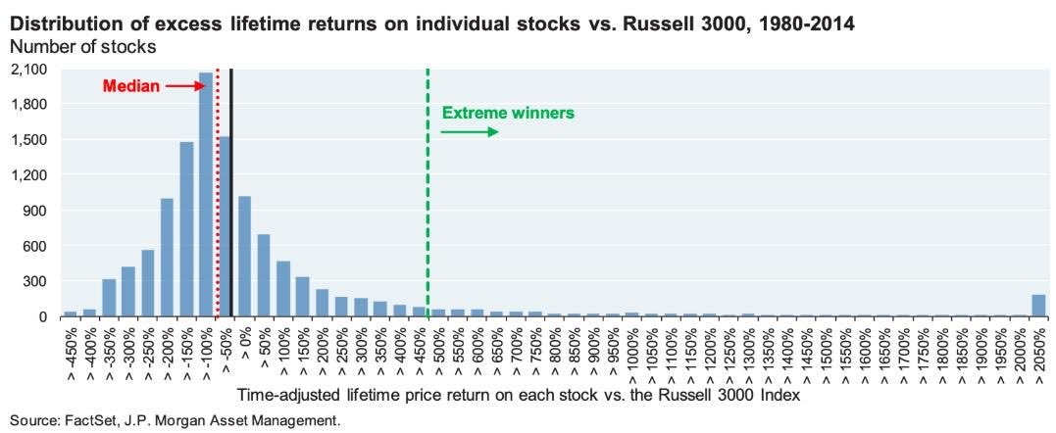
We Have a Tough Investing Environment

Usually, we consider a “conservative” portfolio to be composed of 60% in stocks and 40% in fixed income. Historically, this portfolio benefits from a long-term gain from stocks of high single digits (albeit with volatility), and a steadier interest return from fixed income that usually goes up when stocks go down. At the same time, stocks have a “yield” in that many give dividend income. We can combine the yield from the stock market (which goes down when stock prices go up) with the yield from a fixed income portfolio at various times and see how it compares historically. When yields are at an extreme, we must be concerned about a return toward normal.
From blogger Ben Carlson, here’s a simple chart that shows the combined 10-year treasury yield and the earnings yield on the stock market (using the CAPE ratio¹) for a 60/40 portfolio:
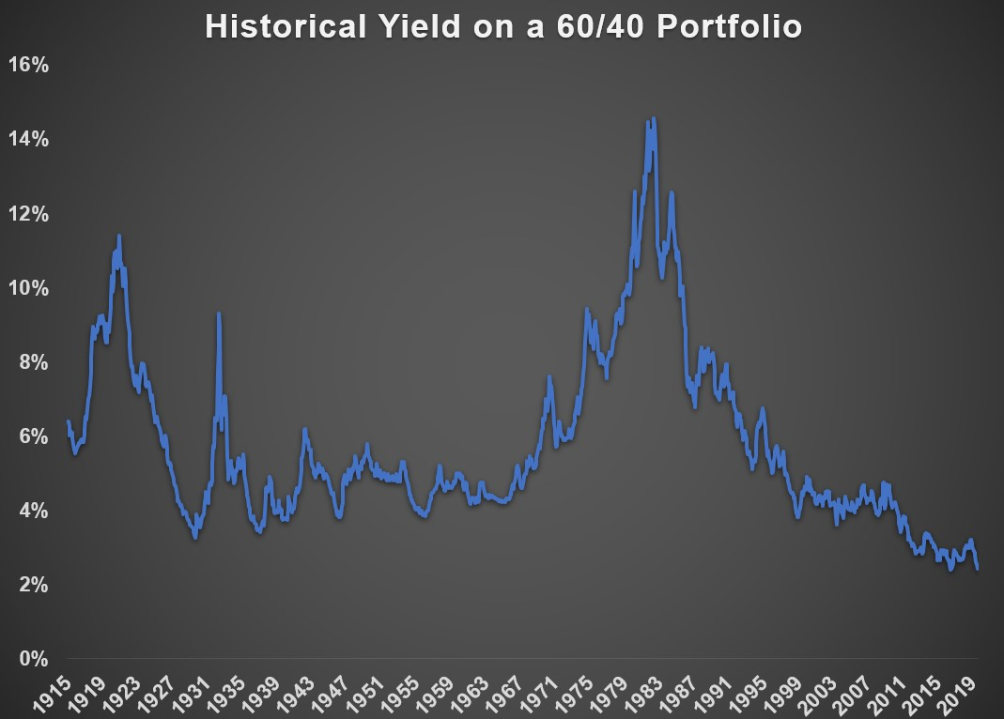
As of the end of August, the 10-year treasury yielded roughly 1.7% while the earnings yield on the stock market was 3.5%%, good enough for a 60/40 combined yield of just 2.4%. That’s tied for the lowest yield on record going all the way back to 1915 (it hit this mark for the first time in 2016).
So, there is nowhere to hide in the US. This keeps us investing Wealth Care LLC portfolios in a diversified portfolio of global stocks and in global fixed income.

Miscellaneous
U.S. life expectancy at birth was:
39 years in 1800
49 years in 1900
68 years in 1950
79 years today. The average newborn today can expect to live an entire generation longer than their great-grandparents.

Google Lens. The 3x Olympic medalist Matt Targett recommended that I check out Google Lens as a tool for transcribing text from physical to digital (e.g., a photo of a book page automagically turns into copy-and-pastable text). I had no idea this app existed (for iOS, the Lens feature is easily found within the Google app), and it turns out that Google Lens does A LOT: “Search what you see with your camera, copy and translate text, find similar apparel, identify plants and animals, scan QR codes and more.” My team and I have played with real-time translation (pointing your phone at non-English text, which translates it to English) and turning paragraphs from physical books and magazines into digital text, which you can then share or simply add to a tool like Evernote. My favorite use has been identifying plants. I’ve tested a number of apps that claim to identify plants, and none have worked. This is the first that has been more than 80% accurate thus far (well done, Google Lens team!). Paying attention to plants has made even the most casual of outdoor strolls fascinating. -Tim Ferris Blog
Interesting-Education and Longevity are correlated
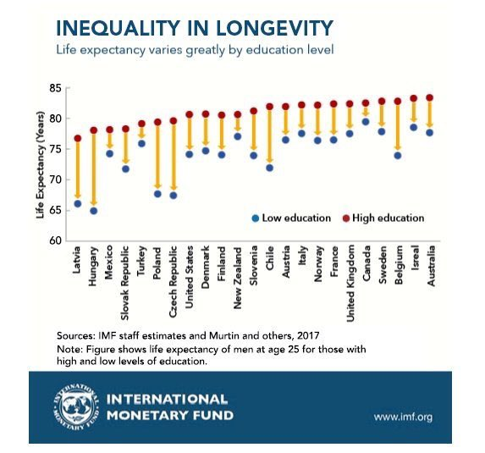

Random Notes

"Gratitude always comes into play; research shows that people are happier if they are grateful for the positive things in their lives, rather than worrying about what might be missing." - Dan Buettner

"A lie can travel halfway around the world while the truth is putting on its shoes." - Mark Twain
"The psychologist Gerd Gigerenzer has a simple heuristic. Never ask the doctor what you should do. Ask him what he would do if he were in your place. You would be surprised at the difference" -
@nntaleb

(Steve here-I find this works well for all kinds of advice)

